|  |  |
| --- | --- |
| Sl No | **Users** |
| 1 | Super Admin |
| 2 | Admin |
| 3 | Change Analyst |
| 4 | Approver |
| 5 | Support Engineer |

1. **Super Admin: -** is the one who has the access and who can control and give the permission/access to all other users.
2. **Admin: -** Admin is the one can share the access with others.
3. **Change Analyst: -** is capable of initiating and Closing a Change Request.
4. **Approver: -** is authorized solely to approve the various levels..
5. **Support Engineer: -** is responsible for implementing a specified number of tasks and Followups for the assigned CR.

Search:

The CR can be searched based on the Plant ID, category, classification,priority, start date, end date, Status and based on the RFC no of the CR

**Login Page**

**Steps to be followed:**

**1.** Login with your Unnati Portal Credential.

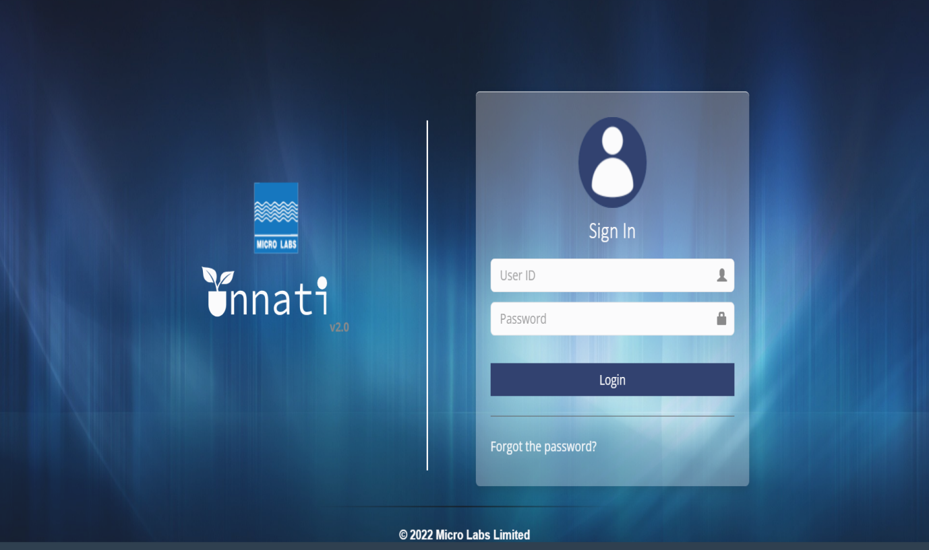

2.Login as an Analyst to Create a Change request(CR).

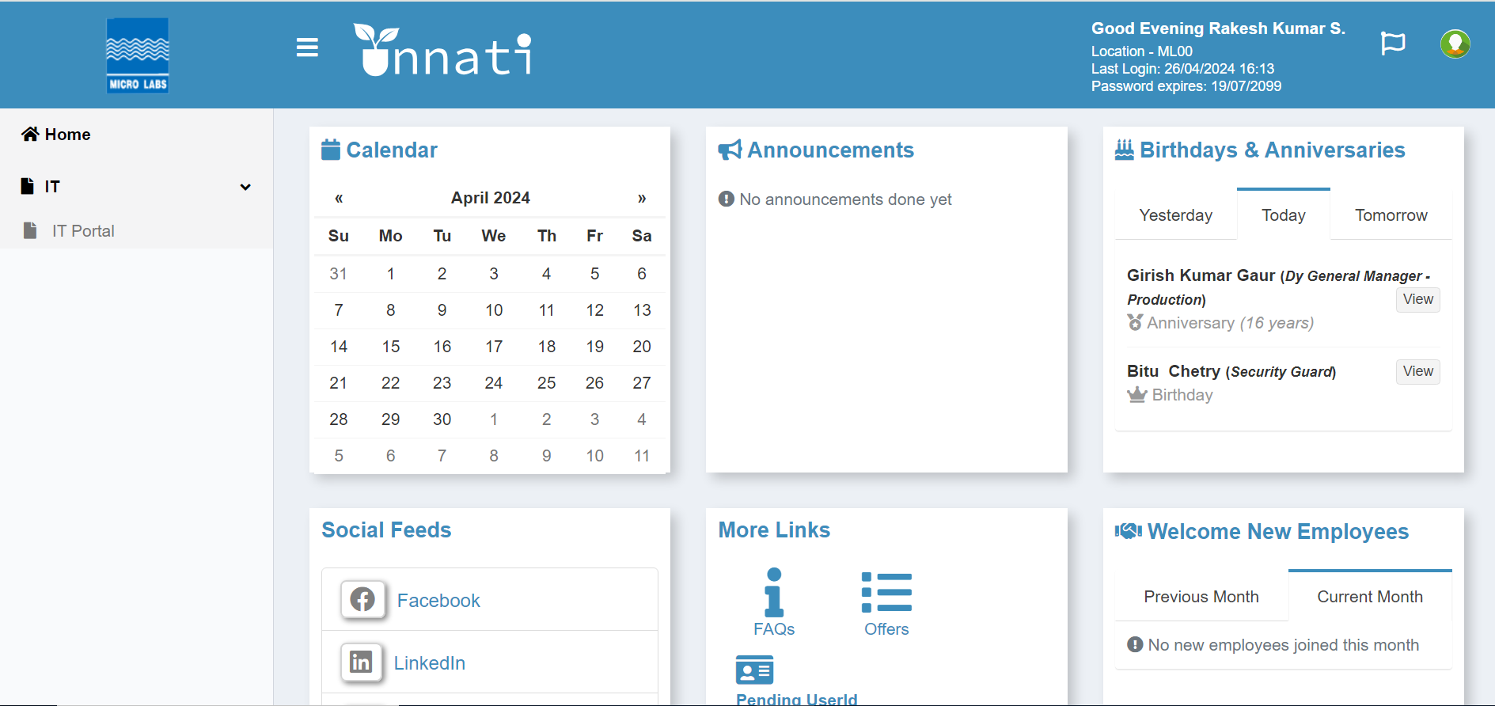

3. From the drop-down menu, select IT and then IT Portal.

4. Click the IT Portal Button.

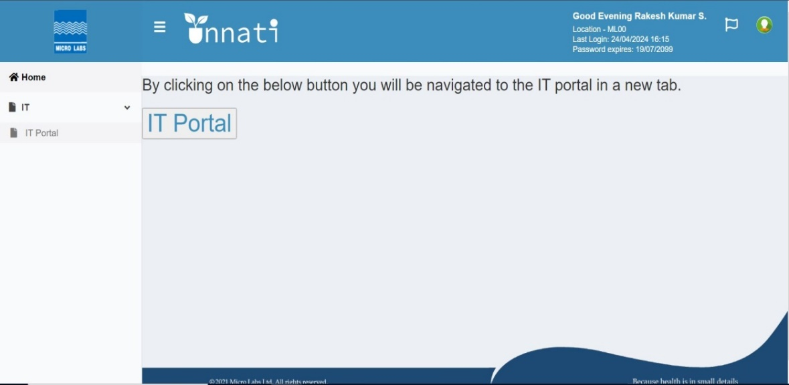

When you click on the IT portal button, the Dashboard will appear. Click to create a new CR, and the Dashboard will remain the same for all users.

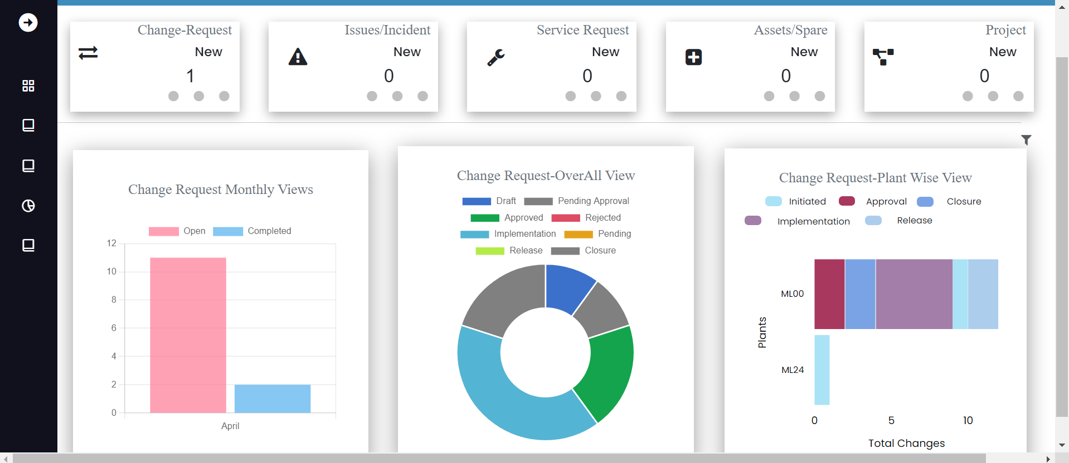

Then click the button (Change New Request) to make a new request.

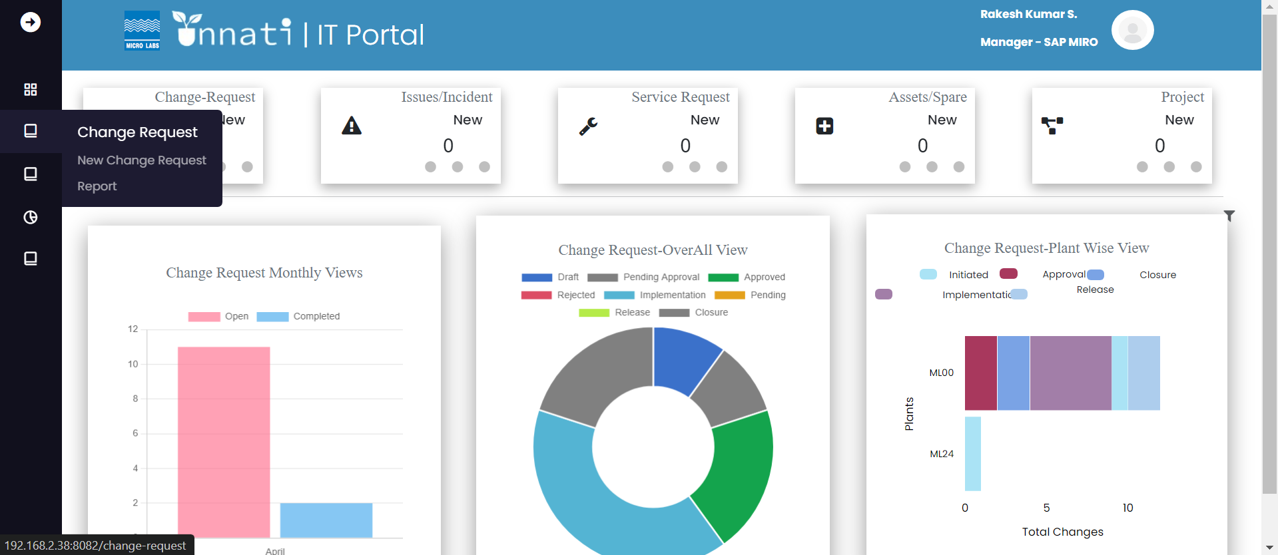

When you click on create new, you will be taken to a form that asks for the required information.   
(Change owner's name, initiator's name, RFC date, plant, reference, reference type, classifications, category, sub-category, nature of change, and priority.) - Change requested by - Change requested on - Change triggered by).   
Note: If the Initiator and Change Owner names are the same, choose the checkbox.   
Note: In the form of CR, you will see various dropdowns; select each one based on your requirements.

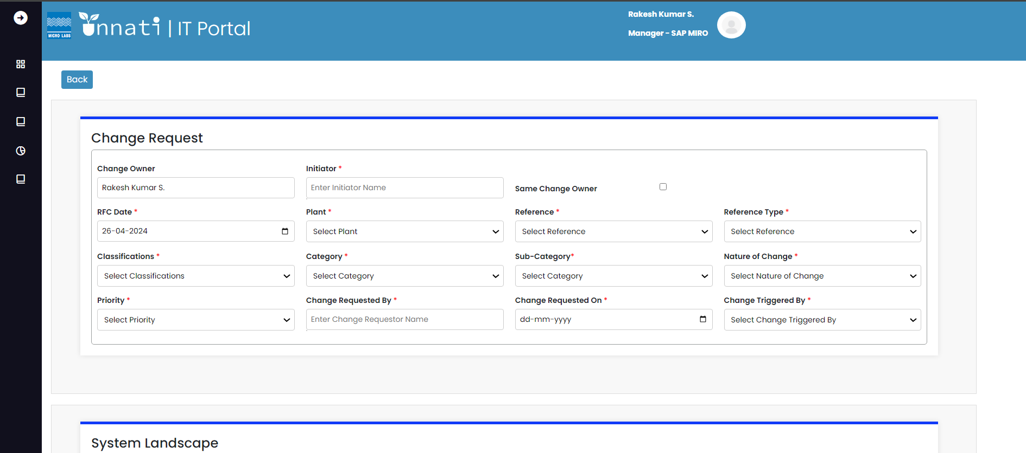

System landscape depends on the classifications and categories.

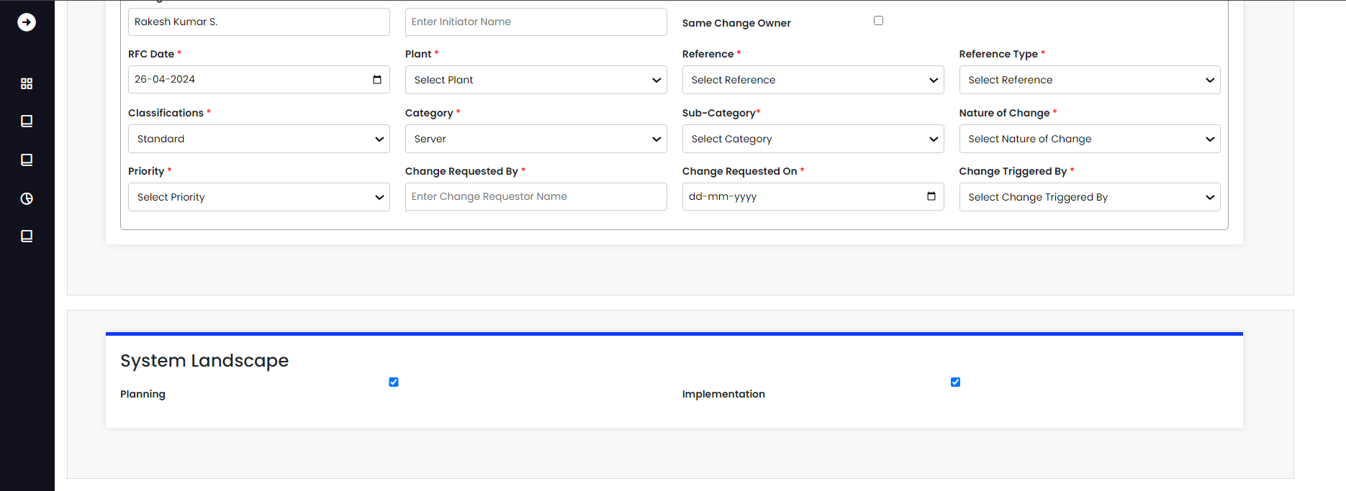

Fill in all the required fields.

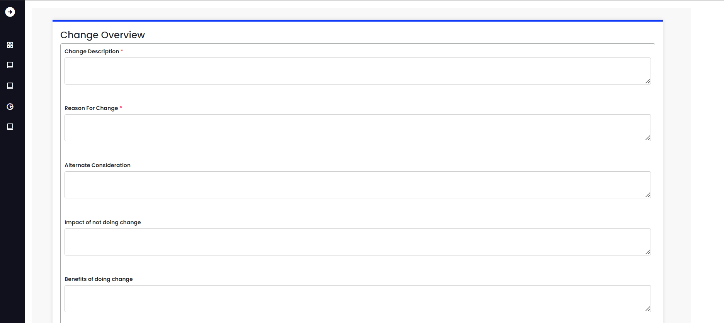

Choose the timeline for the specified task.

(Approximate cost - Currency - Estimated effort - Work days/hours - Expected completion date)

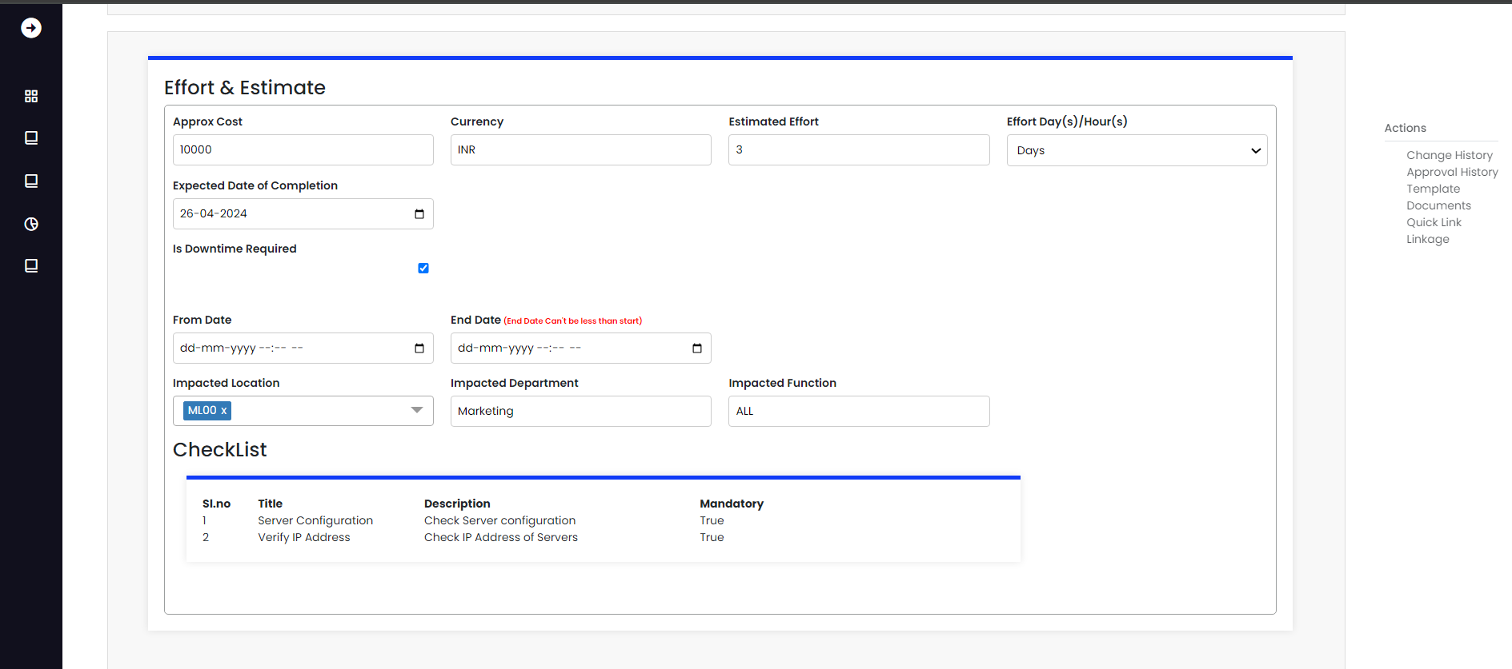

Fill in the Gxp Classifications fields and click Save.

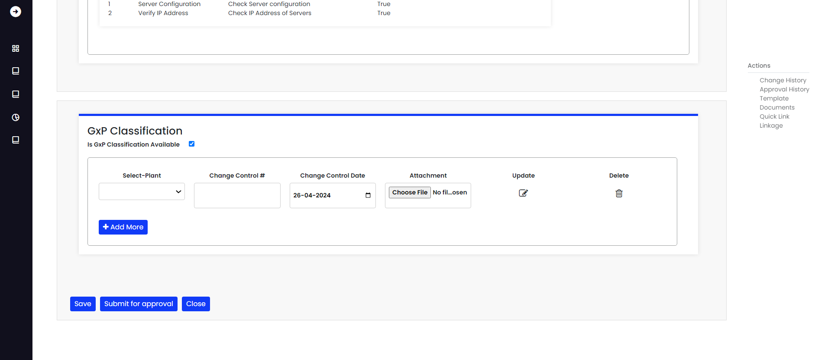

When you click the save button, you will see a popup message that says "Saved successfully."

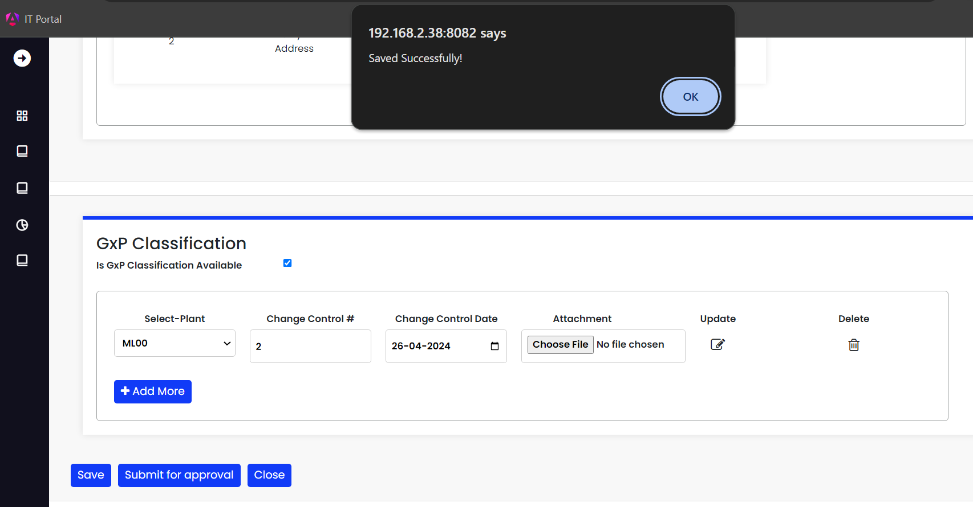

When it is successfully saved, you will see that a draft has been created.

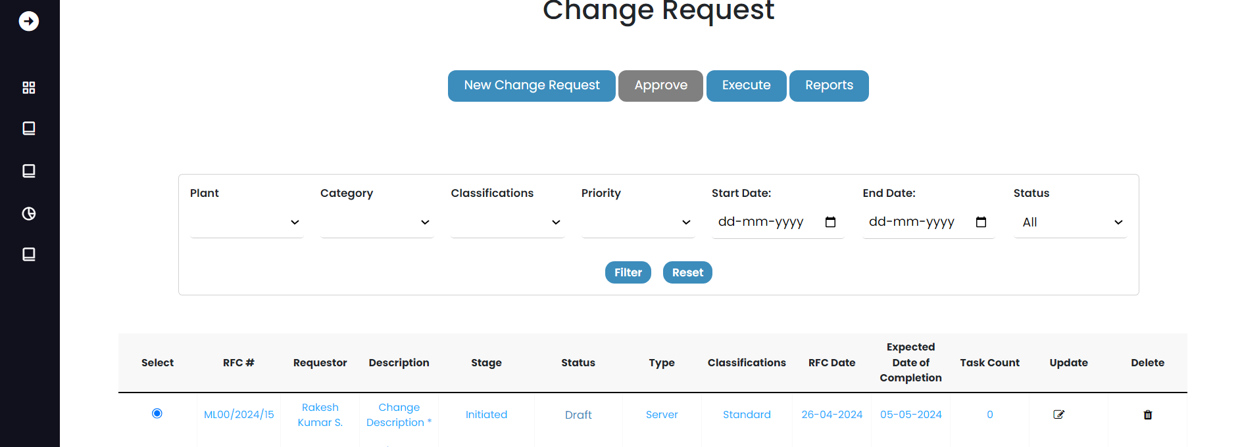

If modifications are required,Click on the radio button for the specific CR, then hit the Update button to begin the modification. Once completed, click the Submit button.



After updating the CR, click the Submit for Approval button.

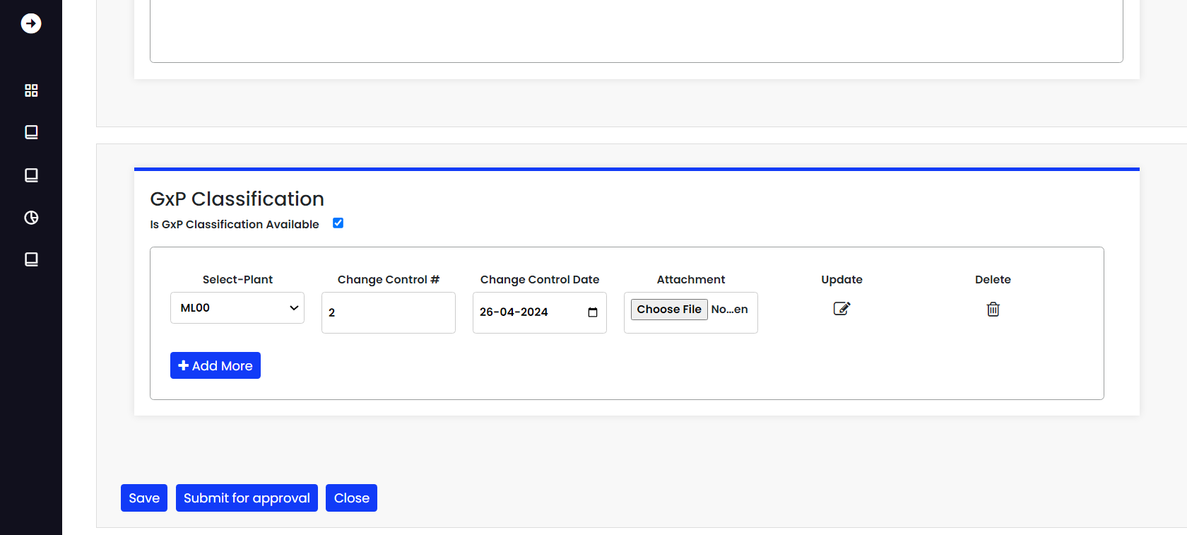

When you click the submit button, you will see a pop-up notification that says "submitted successfully."

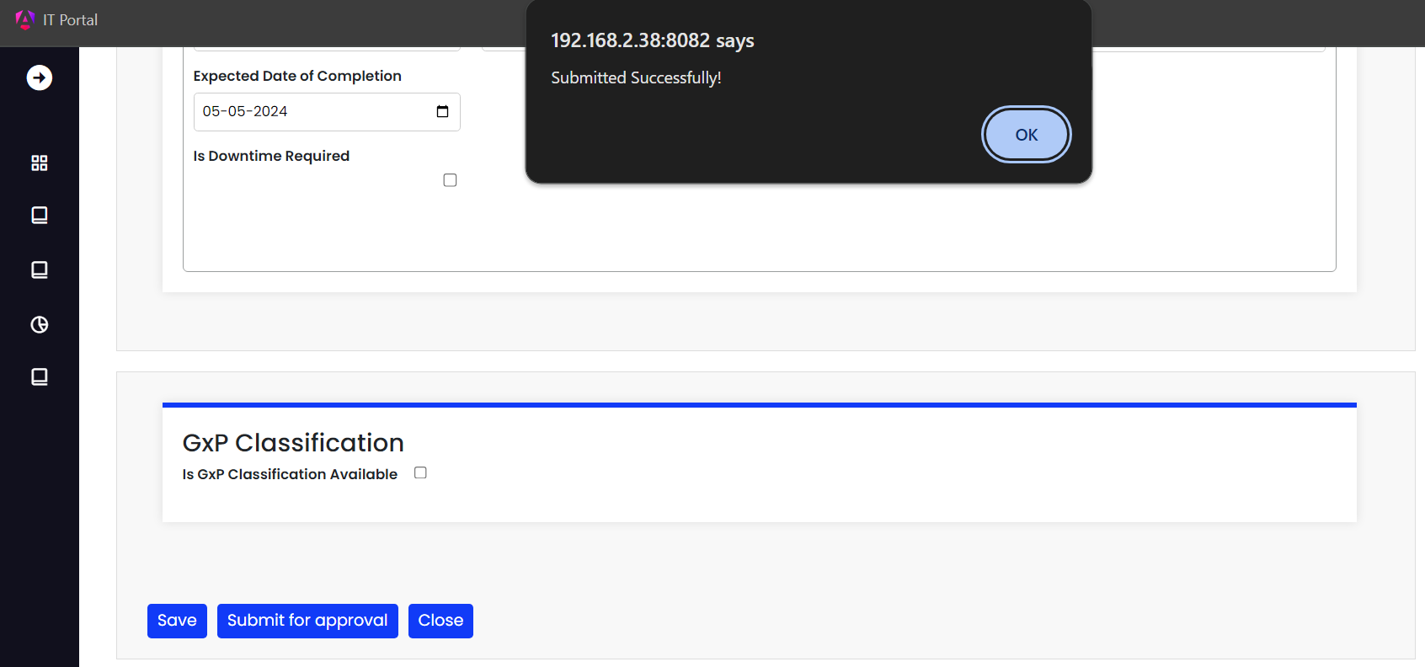

Once the submission is completed, the CR will be updated as pending for approval, as shown below.

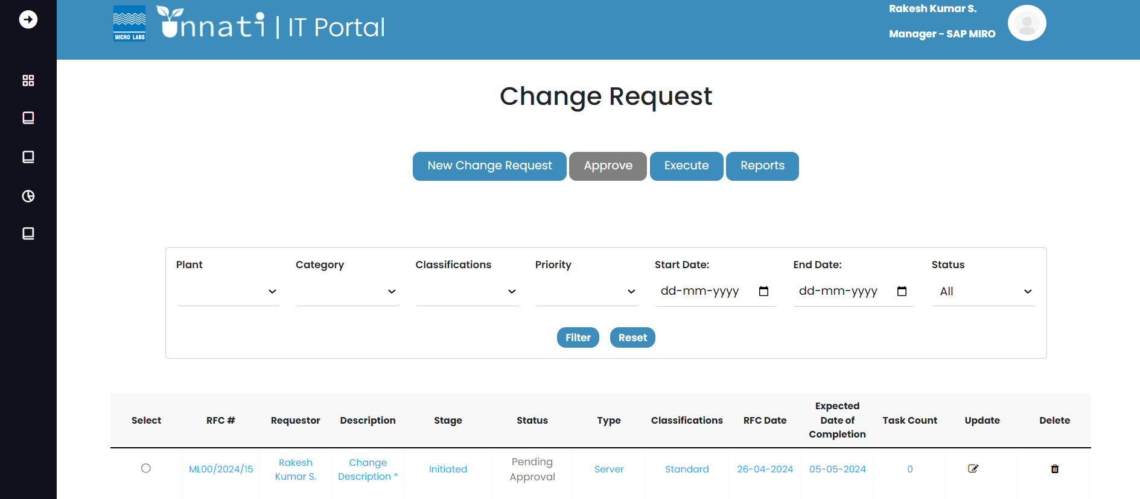

As a Change analyst, you will only see three buttons:

• New change request

• Execute button

• Reports button

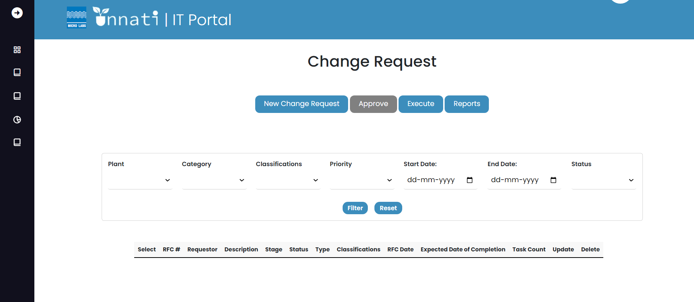

Approver:

As an approver, you can read the CR but cannot alter it. You will only see the Approve and Report buttons.

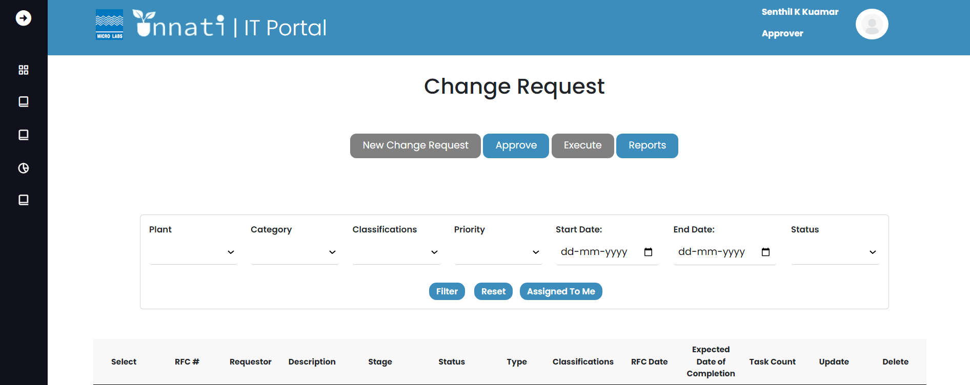

As an approver, you will be able to see the CR in awaiting approval, as well as the specific CR assigned to you depending on the classification and category for the specific user.

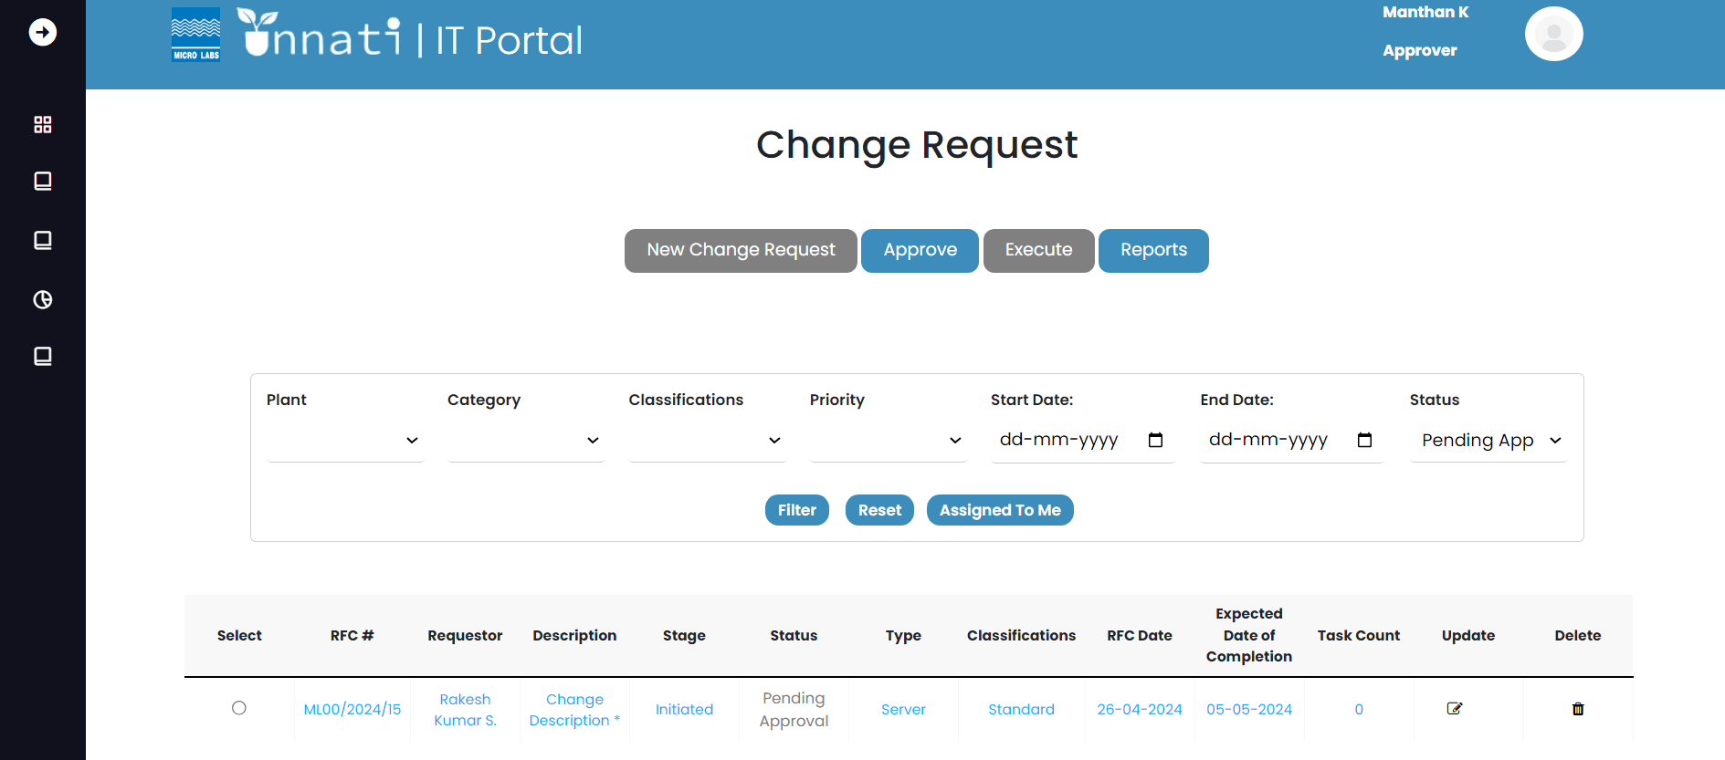

To approve the CR, pick it by clicking on its radio button and then clicking the Approve button.

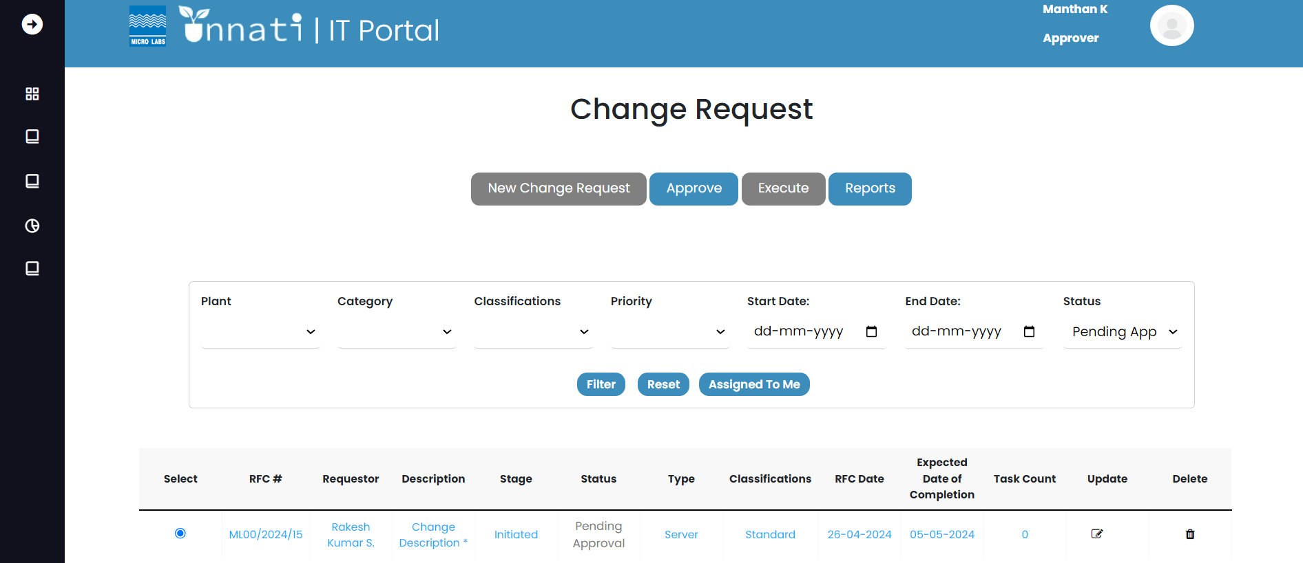

When you open a CR, you will see the rfc number, creation date, and status bar. If the CR is not yet authorized, the status will be highlighted in orange, indicating that the current status has not been updated.   
By clicking on the RFC button, the user may read the CR details but cannot alter them. The Blue button for approver indicates that you are in approver phase level 1, and the History button allows you to view the history of the specific CR. It also provides the name of the particular approver.

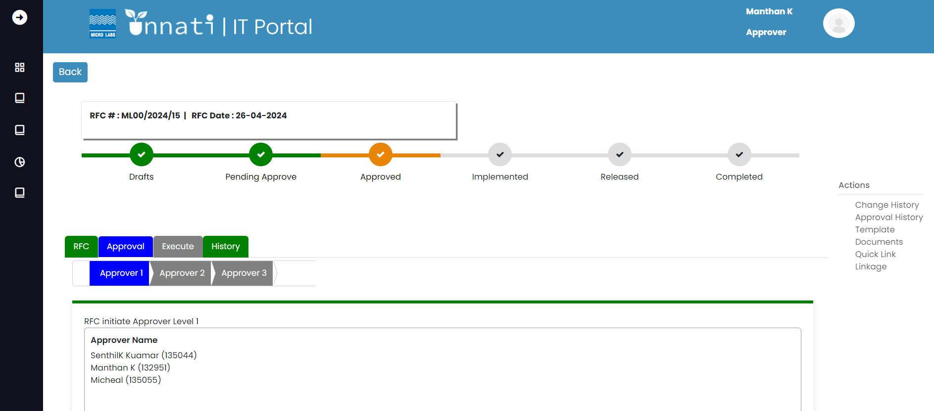

In this part, the user can record notes and attach documents in the attach document section before clicking on approve. By doing so, you are approving the level 1, and the user can reject the CR for any valid cause or click on seek clarification for further explanation/update.

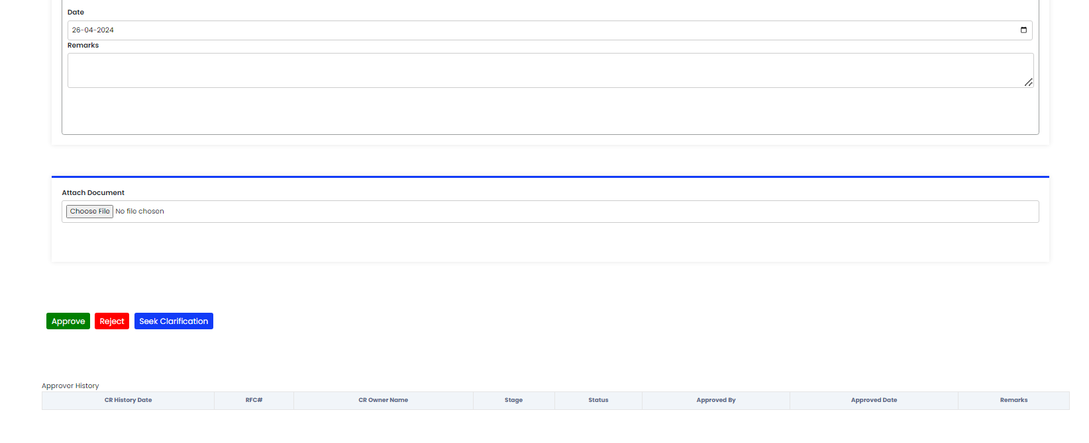

The status has been updated to approved level 1 because you approved it.

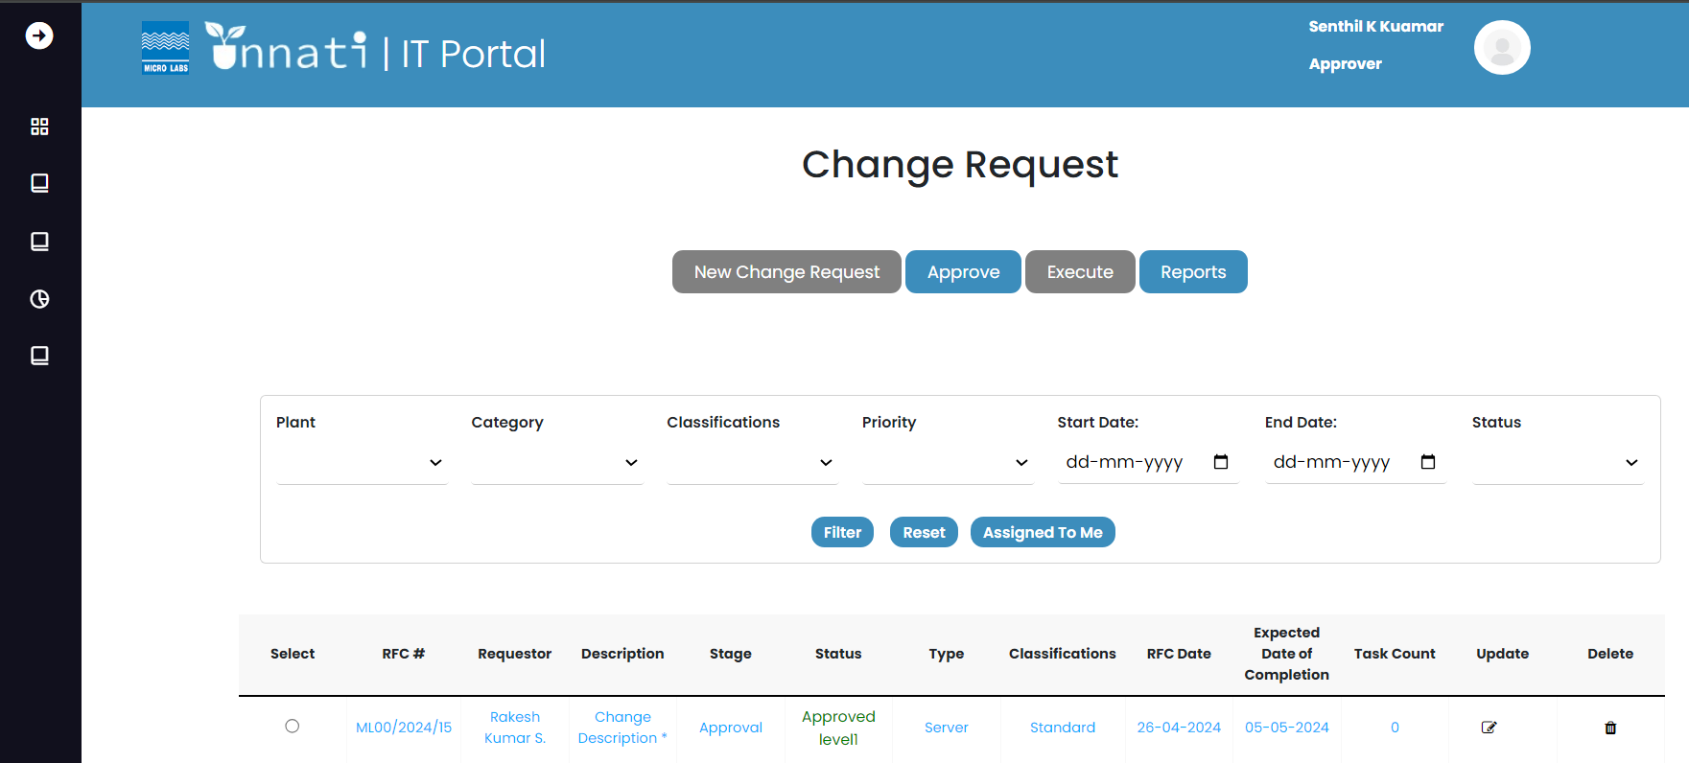

Now that we are in the level 2 phase, you can see that the approver level 1 colour has changed from blue to green. As the level 1 approver, you will not be able to approve the level 2, and you will not be able to see the level 1 approver's name or the following buttons- Approve, Reject, and Seek clarification. So, the following CR must be approved by level 2 approvers.

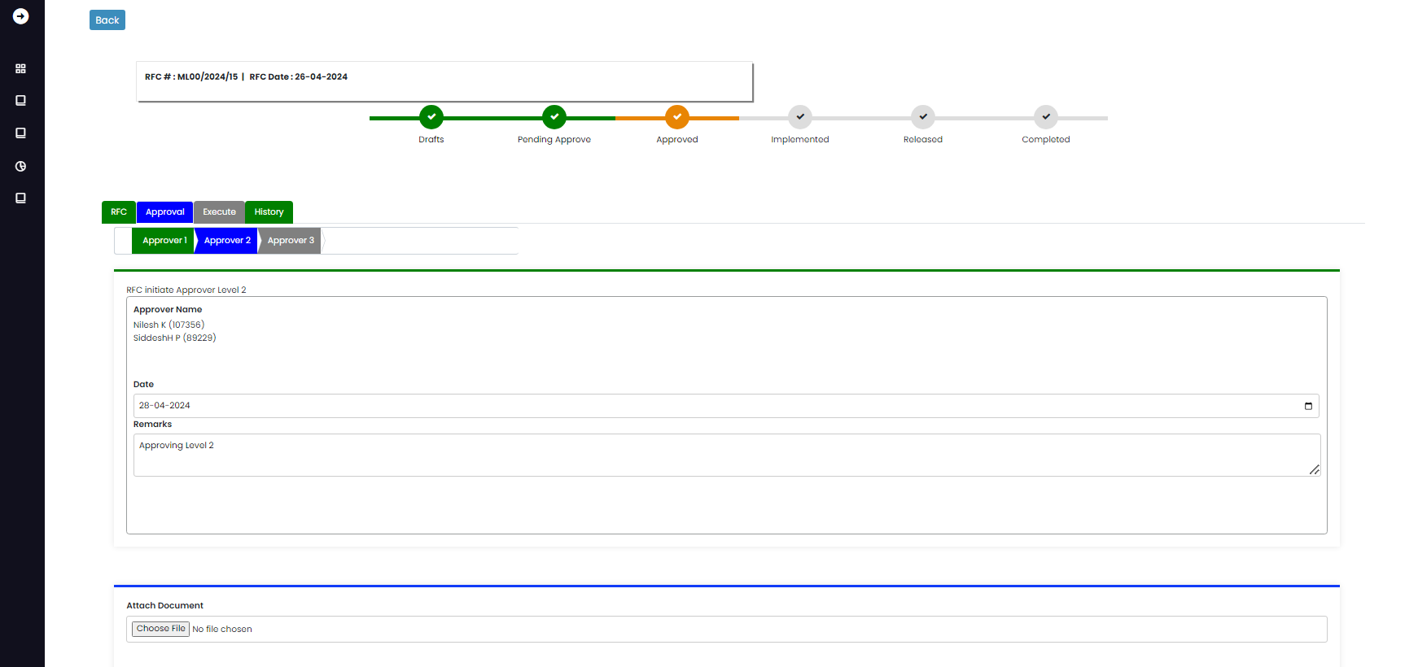

Level 2 Approver:

As a level 2 approver, you can see that approver2 is blue, indicating that you are in the approval level 2 phase.

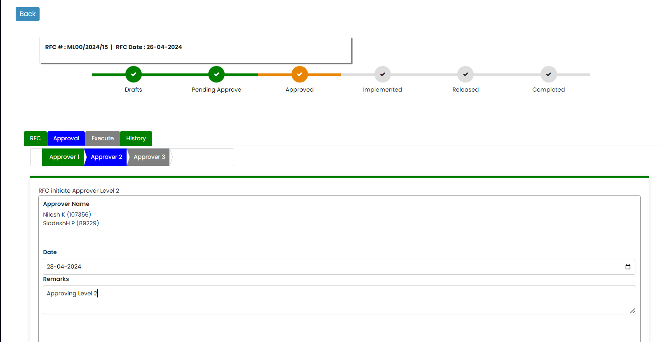

You can update your notes here, as well as read prior remarks in the approval history area. Once you update your remarks and click the approve button, the remarks are updated.

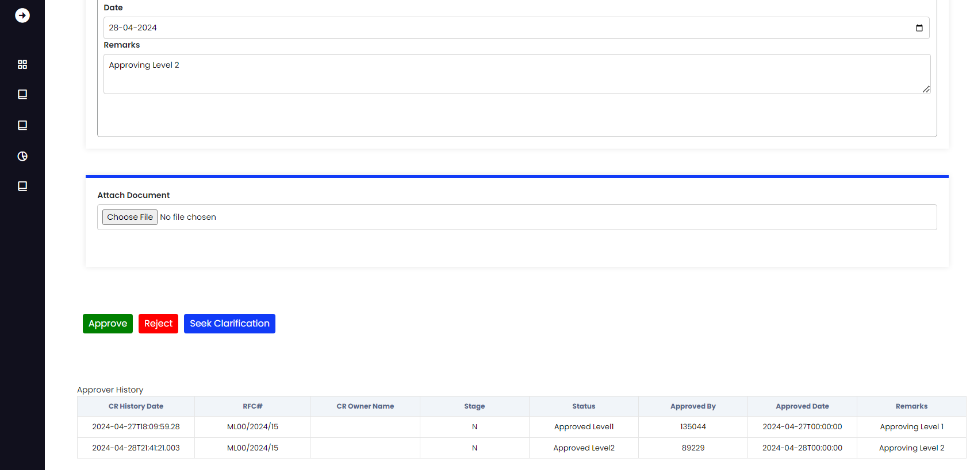

As approval level 2 was approved, the CR status was changed to Approved level 2.

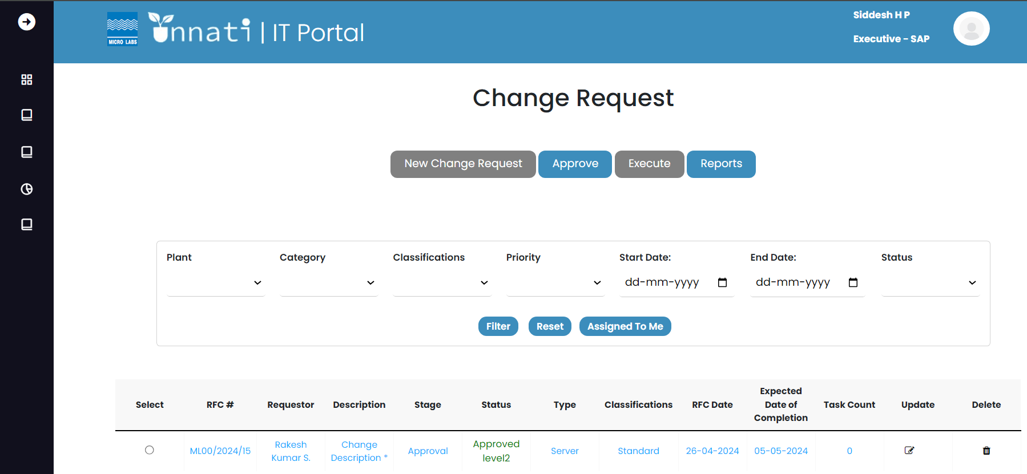

As we enter the Approver level 3 phase, you will notice that the approver level 1 and level 2 colours have changed from blue to green. As a level 2 approver, you will not be able to approve the level 3 and will not be able to see the name of the level 2 approver or the following buttons- Approve, Reject, and Seek clarification. So, the following CR must be approved by level 3 approvers.

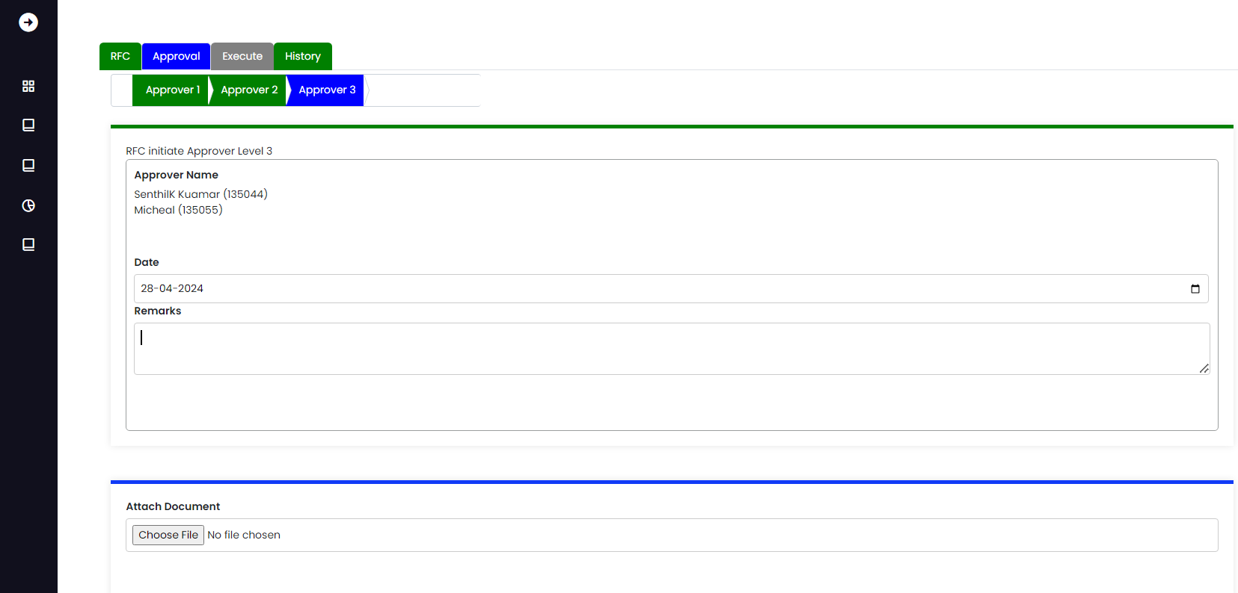

Level 3 Approver:

As a level 3 approver, you can see that approvers 1 and 2 are green and approver 3 is blue. This indicates that you are in the approval level 3 phase and that your name can be found in the Approver list.

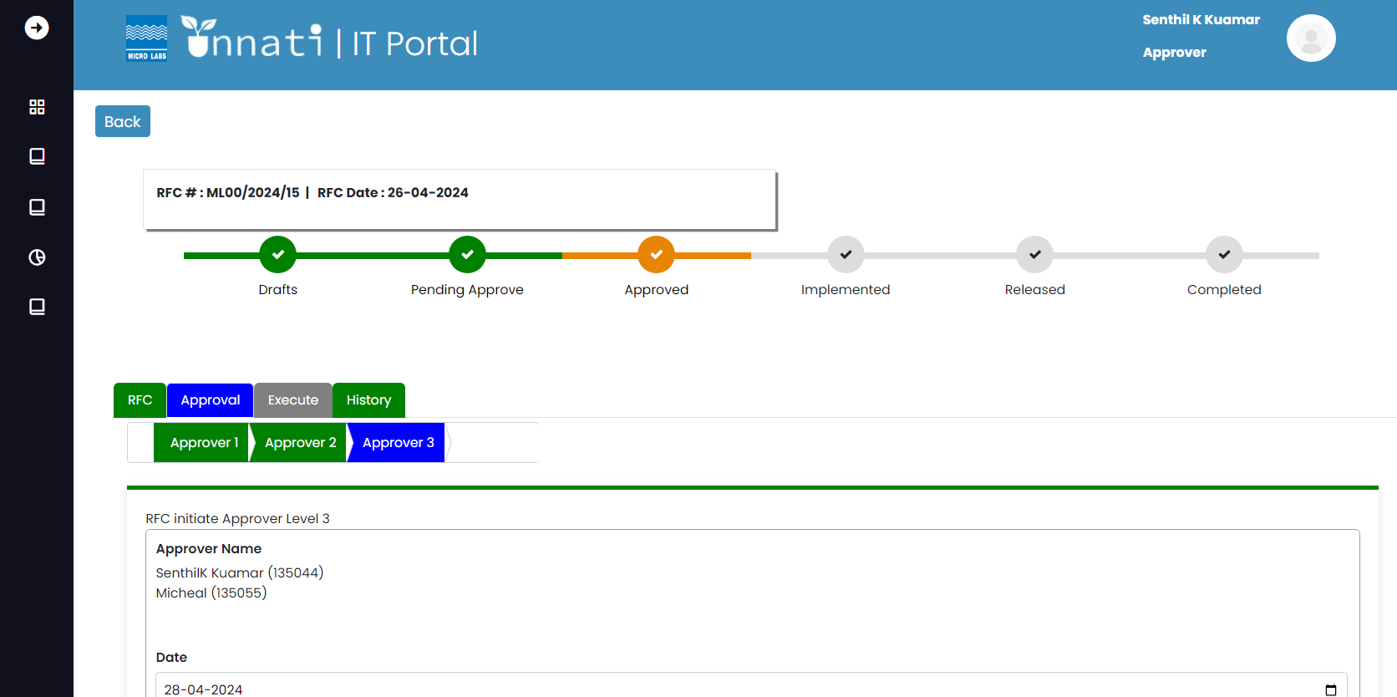

After updating/writing the remarks and clicking the approve button, the remarks were updated, the status on the status bar changed to Approved, and all approver levels turned green in colour.

.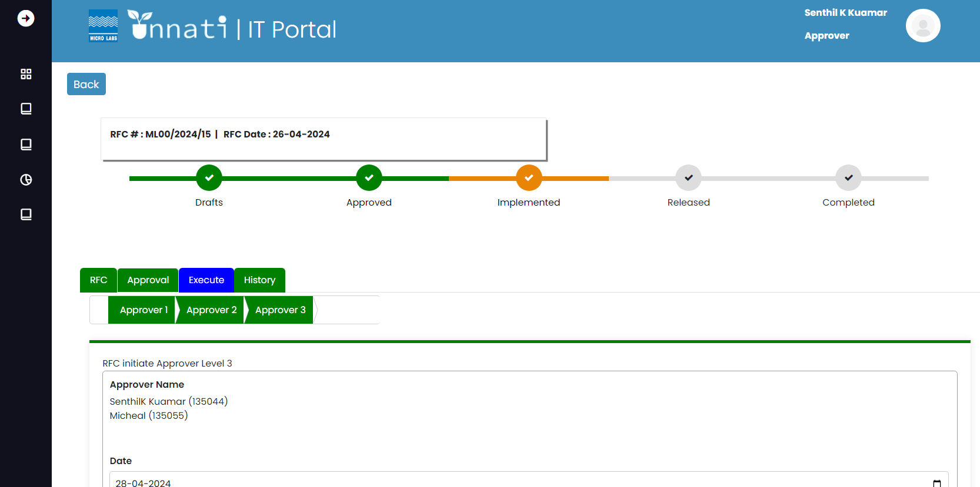

All of the approvers' level data and remarks were updated in the Approver history table.

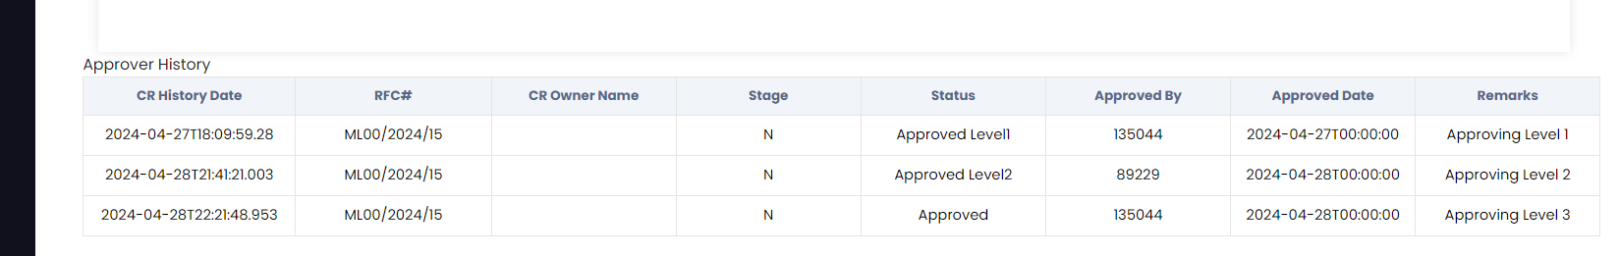

The status of the CR was changed from approved level 2 to approved.

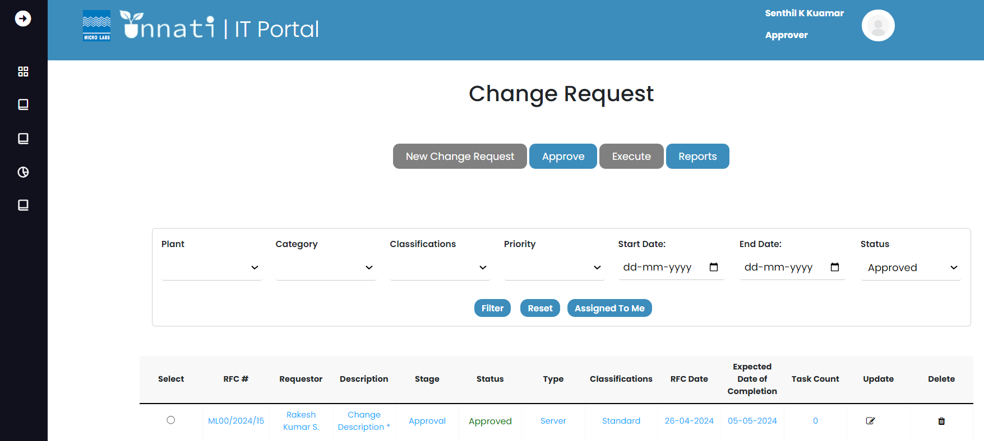

Execute-Implementation:

The change analyst/support engineer is in charge of the task created. Because we are in the implementation phase, the status bar for implemented is orange, all approver labels are green, and the execute tab is blue, indicating that we are in the execution phase of the CR. The system landscape is determined by the classification and category of the CR.

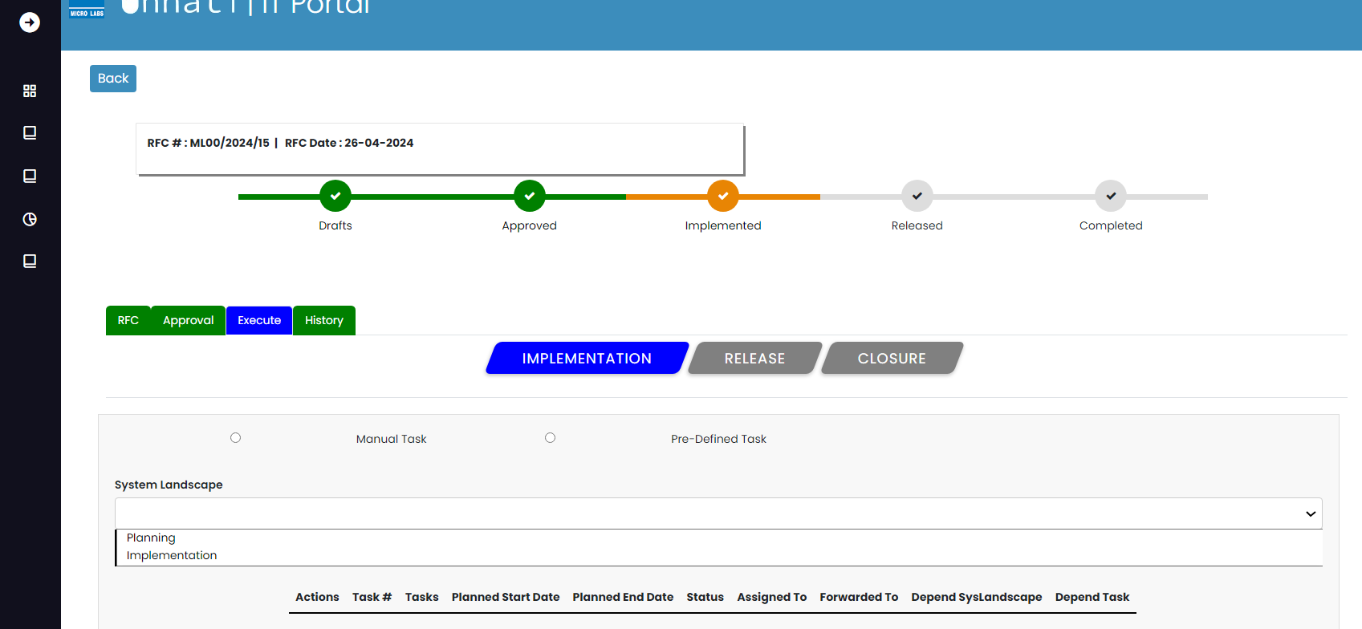

Task creation:

As we have planning and implementation in the system landscape, we will build a planning task. To create a task, select planning from the dropdown. Once planning is selected, the add new task button shows on the left side of the bottom. Click on it.

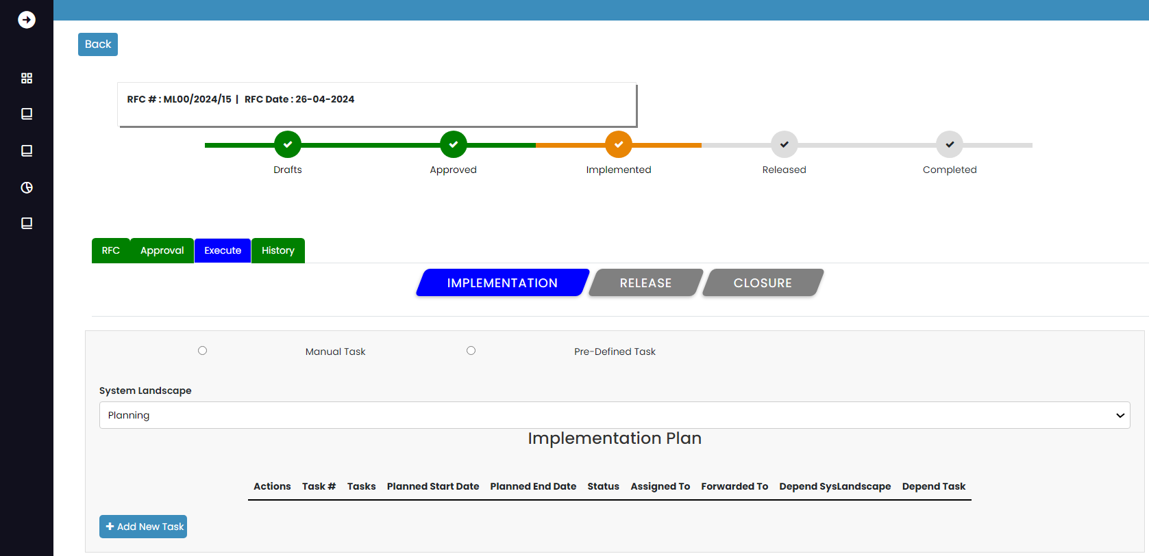

This is how the new task form appears after clicking the Add New Task button.

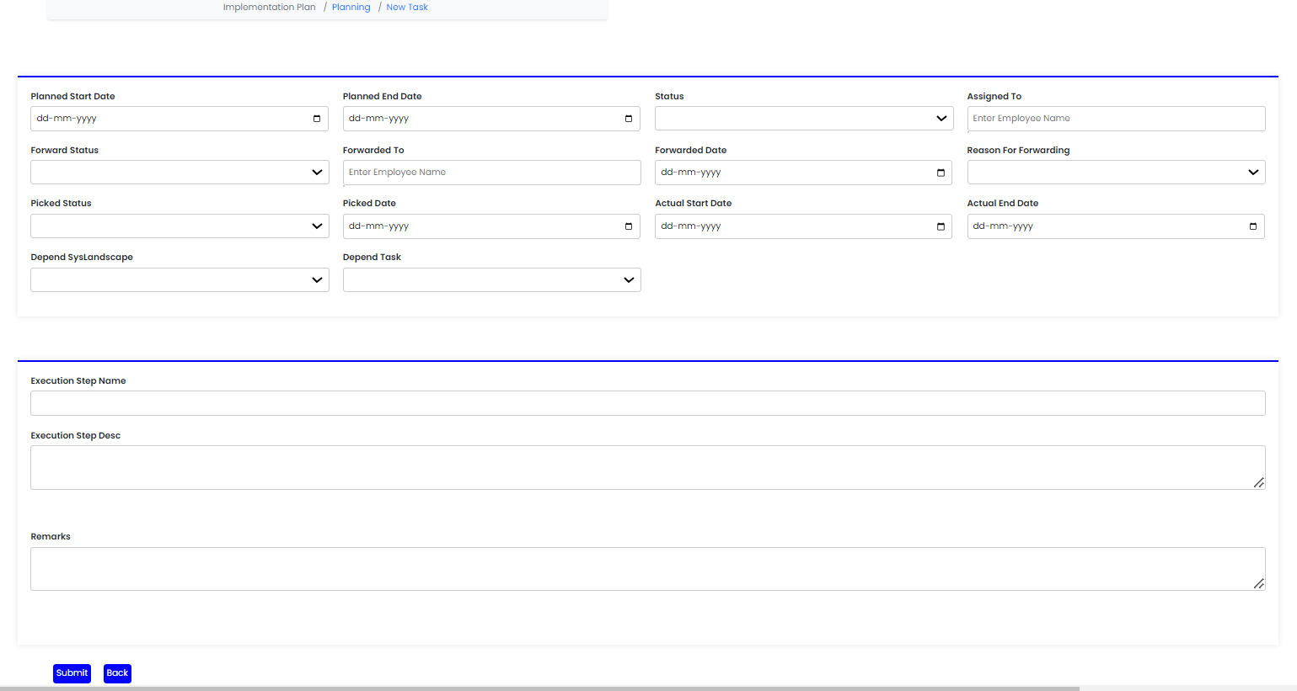

Fill out all of the form's mandatory fields.

Note: Because this is the initial task, it will be independent, which means there will be no dependent tasks. Once you have entered the appropriate data, click the submit button.

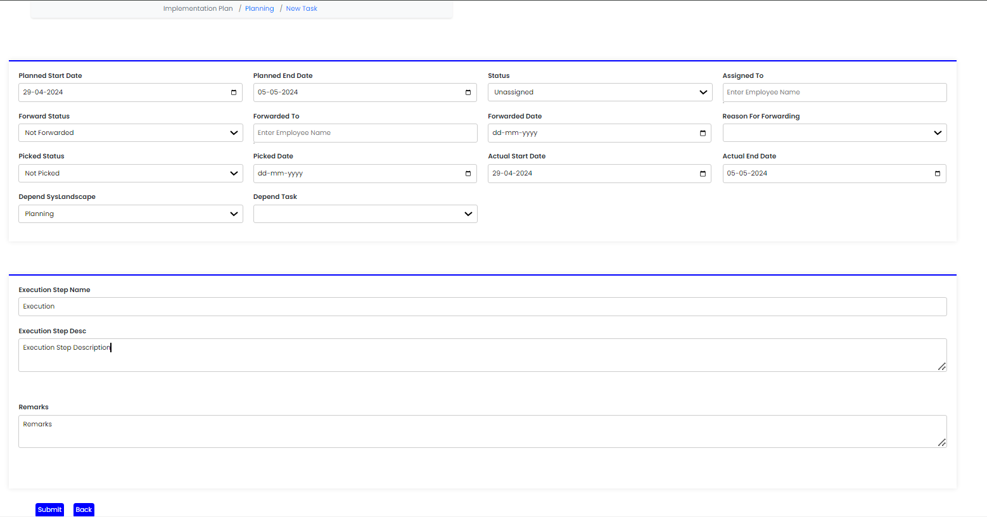

When you submit it, you will see a pop-up notification saying "Added successfully."

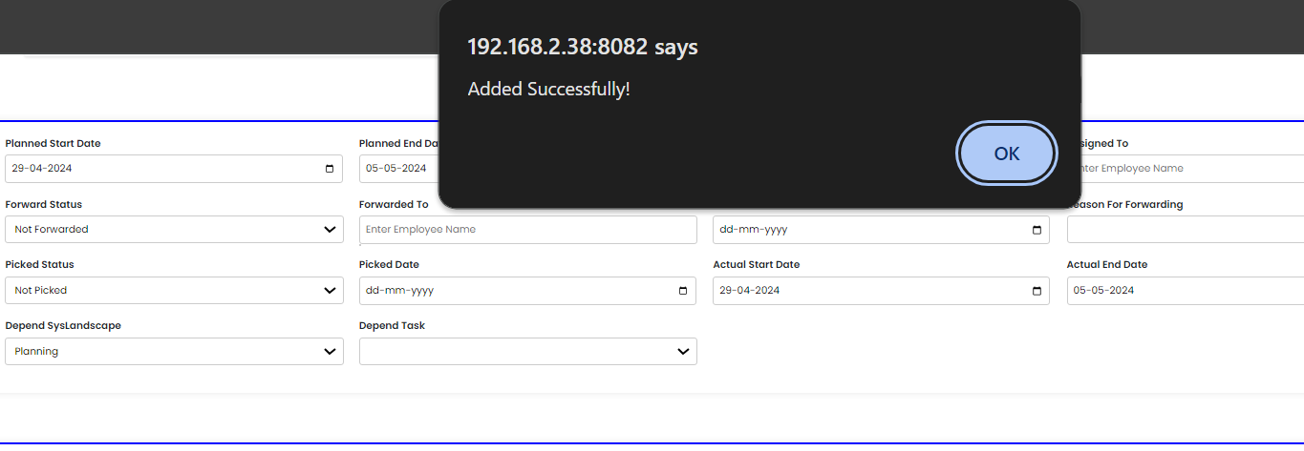

As the task was generated, this is how it appeared. As we have generated one task, it is displayed in the table, which includes the task number, task name, intended start date, finish date status, assigned to, forwarded to Depend system landscape, and depend task. We can add n number of tasks.

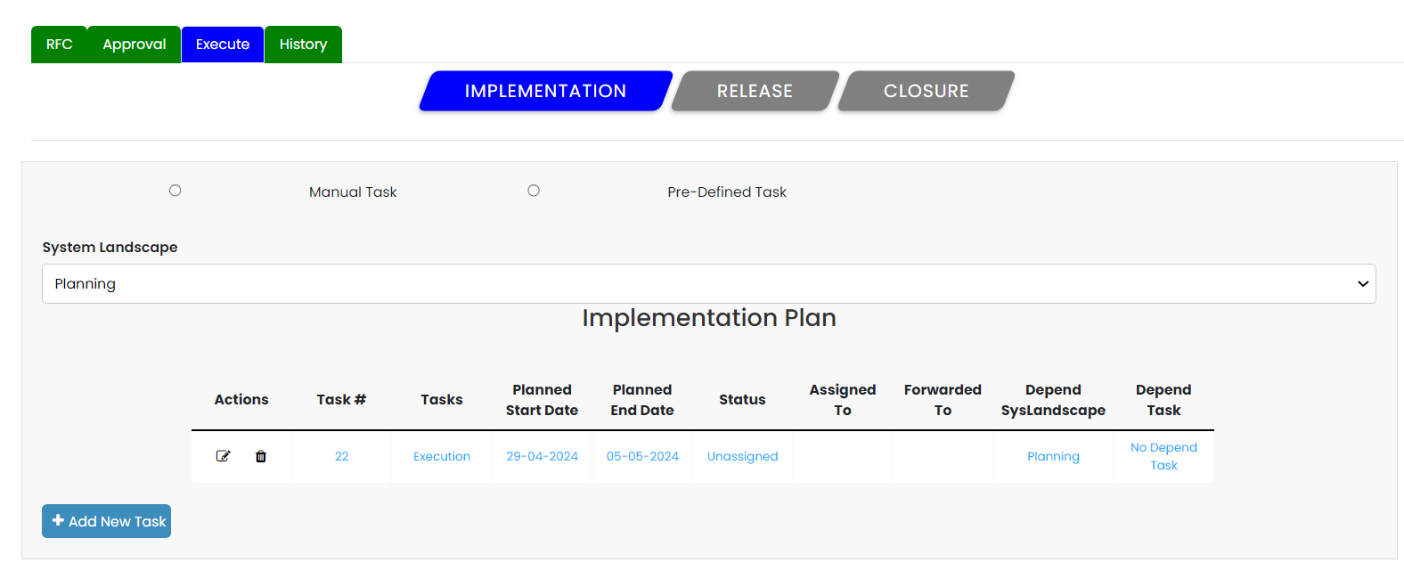

If you want to add another task, click on Add New Task and create a new one as it will be the second task and it can be dependent task.

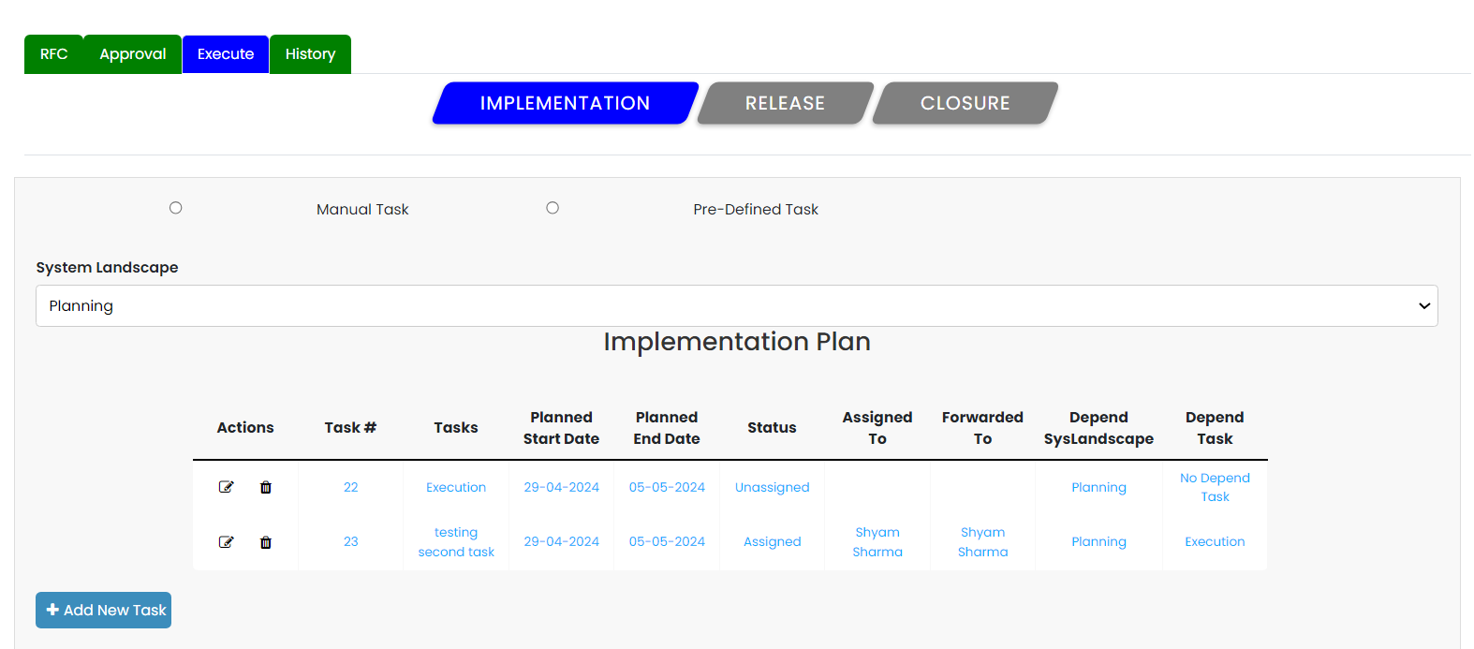

Will create a task for Implementation; to create a task, select Implementation from the list; once selected, click the Add New button.

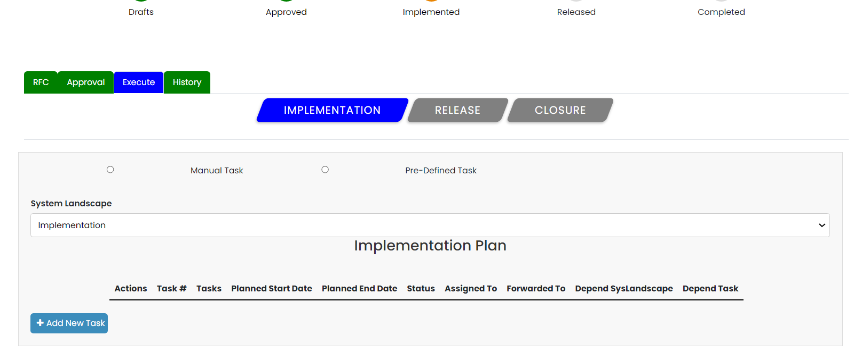

We have established one job for implementation, and it is shown in the table.

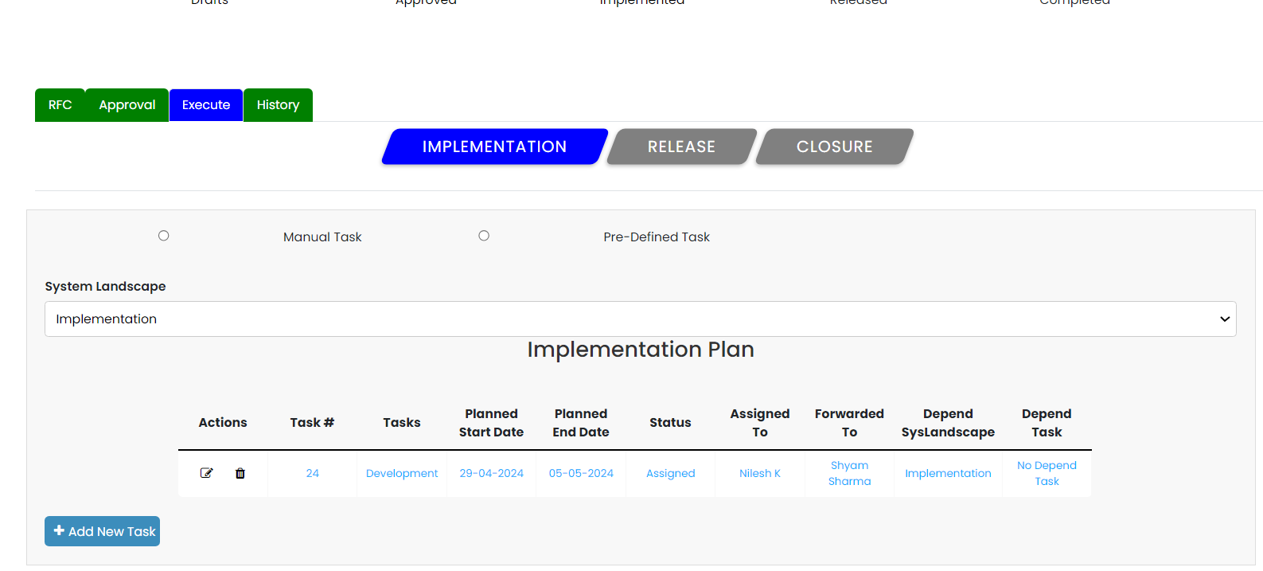

To proceed to the next step of execution, which is release, all created task statuses must be updated to completed; even if one task status is assigned, unassigned, or on hold, the submit for release button will not show. To update the status of a task, select it from the landscape and click the update button, which will shift the status to the next level until it is complete.



Because there were three tasks generated, the task count is displayed on the CR's home page, and the stage updated as implementation, status for the same CR has been updated as implement.

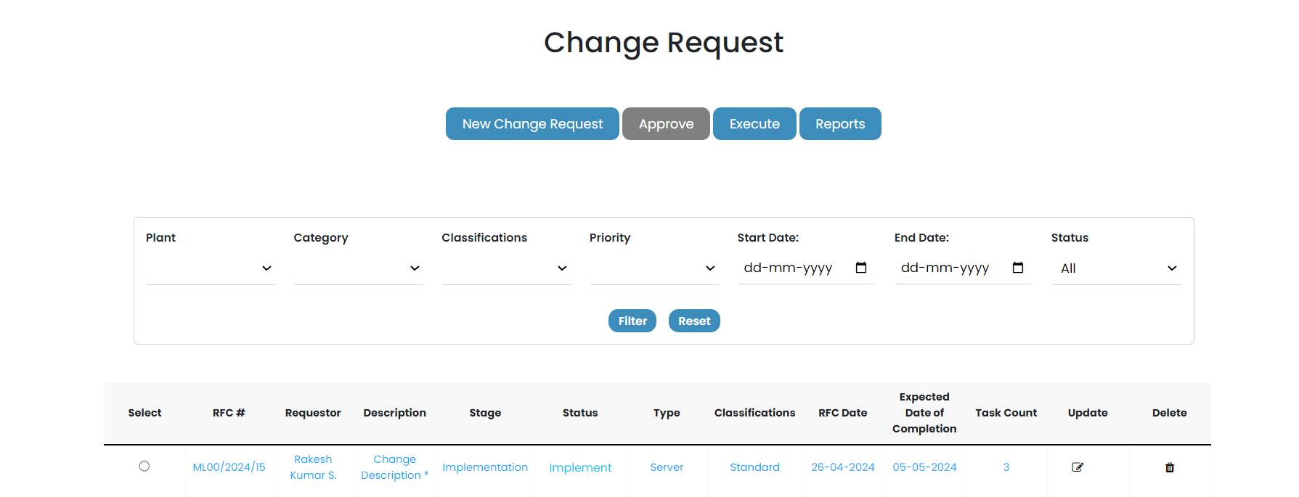

Once all of the task statuses have been updated to finished, the submit for release button will appear.

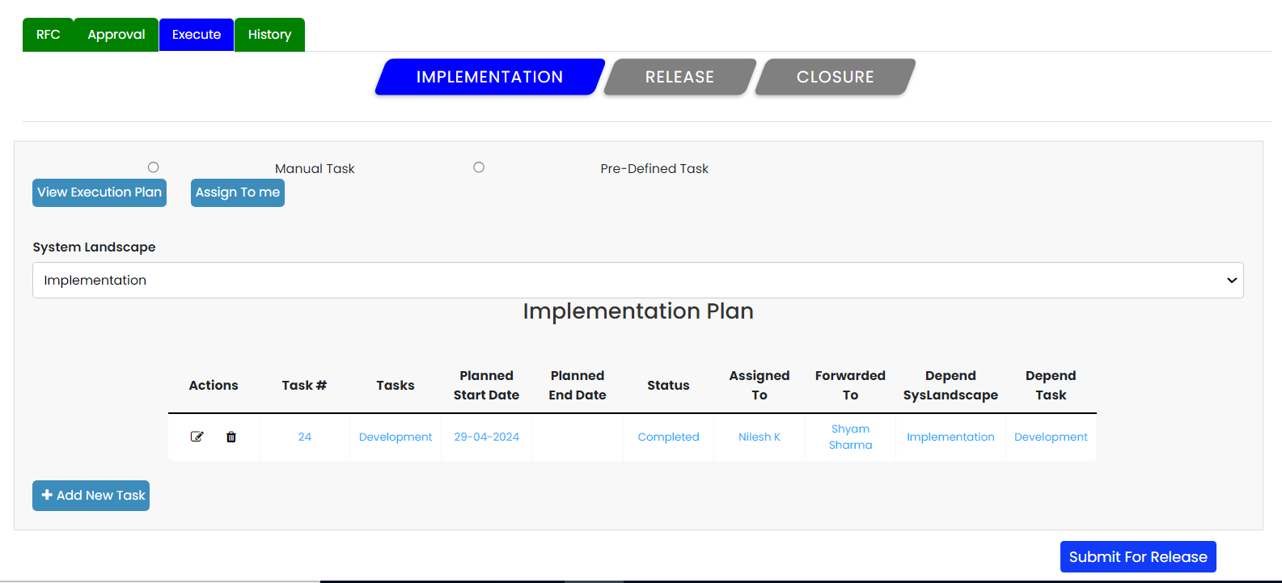

When you click on the submit for release button, you will see a notice show up saying that it was successfully implemented.

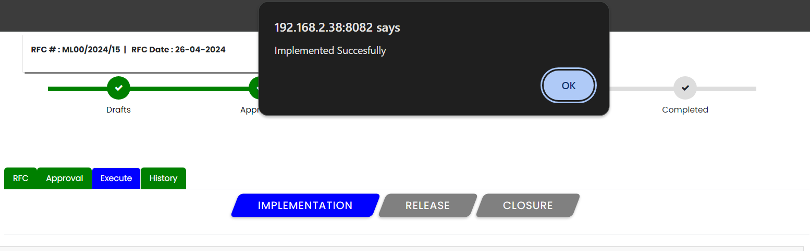

And the status will have been updated to reflect the implementation.

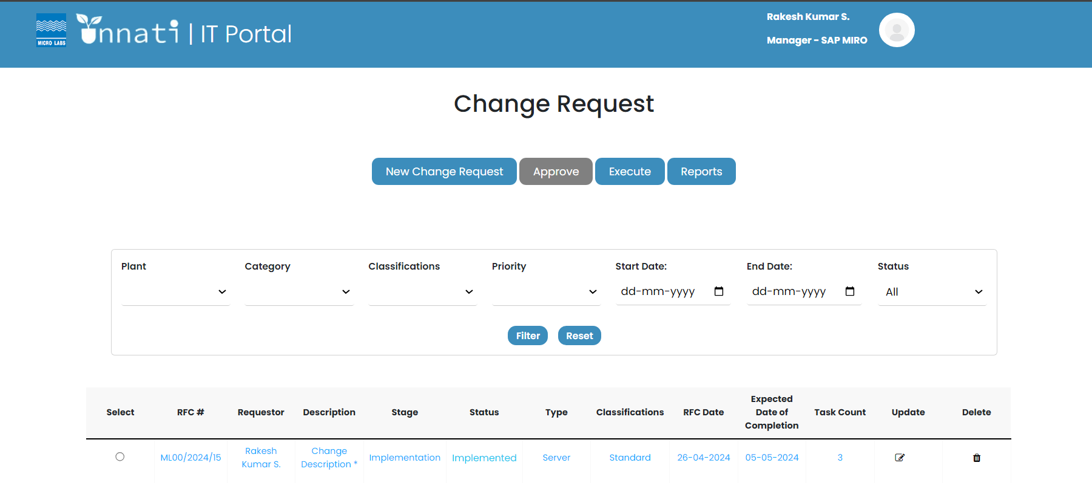

As the implementation is done, the status bar of the specific CR is updated as implemented, and the implementation button color changes to green, while the release button changes to blue.

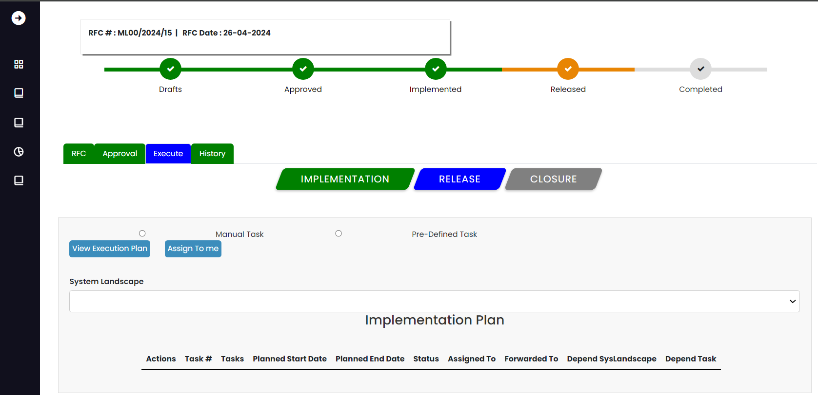

Release Approver:

Select the specific CR and click on approve, execute, and release. By doing this we will enter the release approver phase 1 Once in the release approver, click on Approve 1, capture the Remarks, and click on the Approve button.

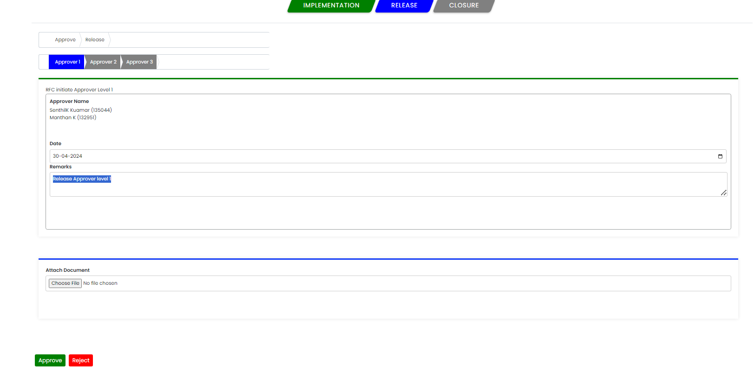

When you click the approve button, a popup message will appear saying that you have approved successfully.

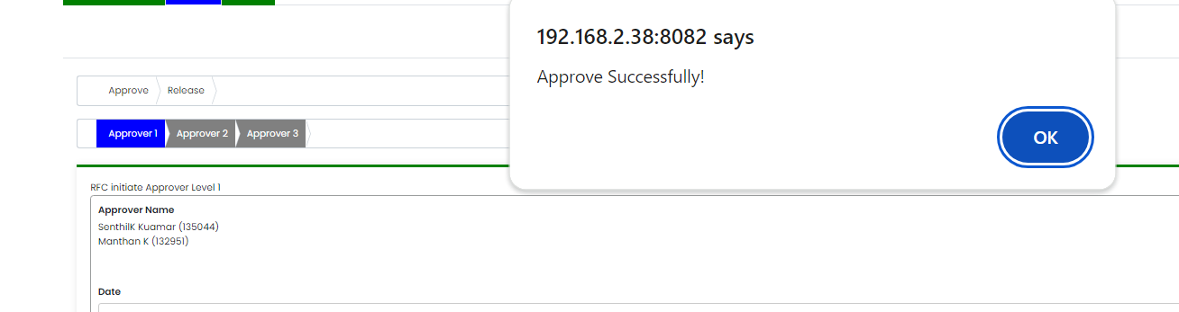

The status of the specific CR has been updated from stage to Release, and the status is Approved level 1.

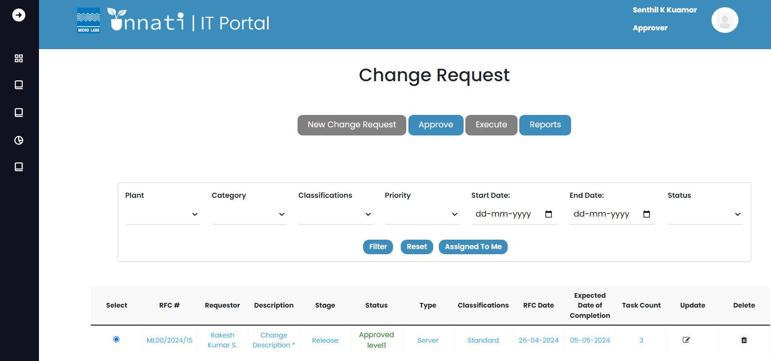

Now that we are in the level 2 phase, you can see that the approver level 1 color has changed from blue to green. As the level 1 approver, you will not have access to approve the level 2 and will not be able to see the name of the level 1 approver and the following buttons- Approve and Reject. So, the following CR must be approved by level 2 approvers.

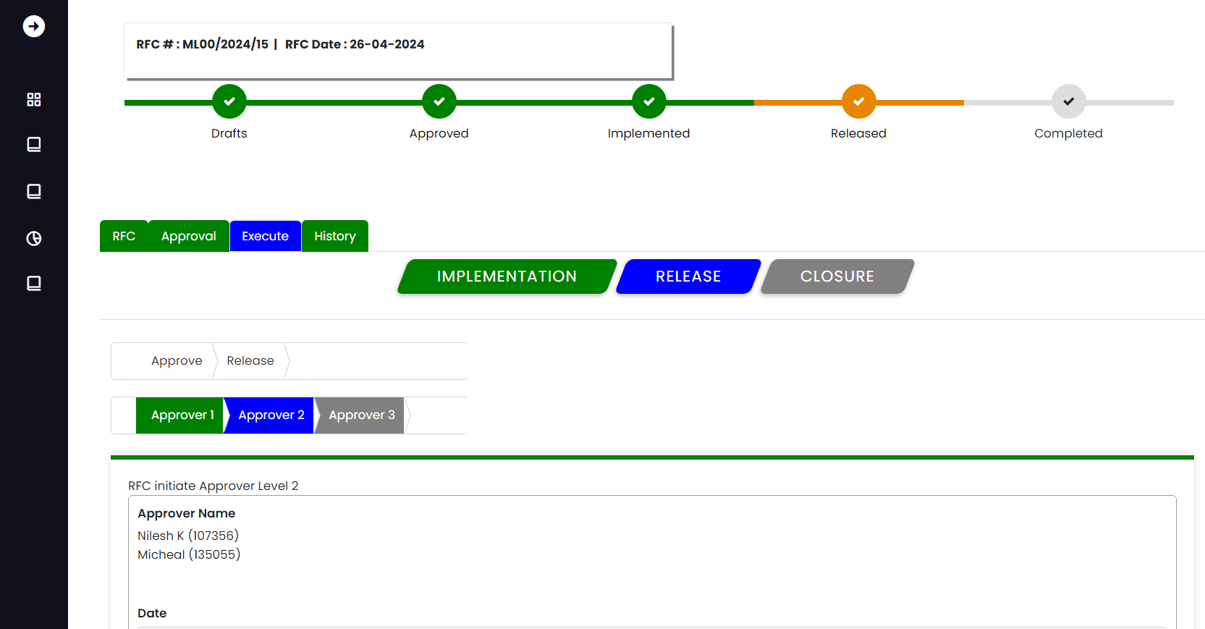

Level 2 Approver:

As a level 2 approver, you can see that approver2 is blue, which indicates that you are in the approval level 2 phase. Capture your remarks and click on approve, and the remarks are saved and a popup message appears stating that you have approved successfully.

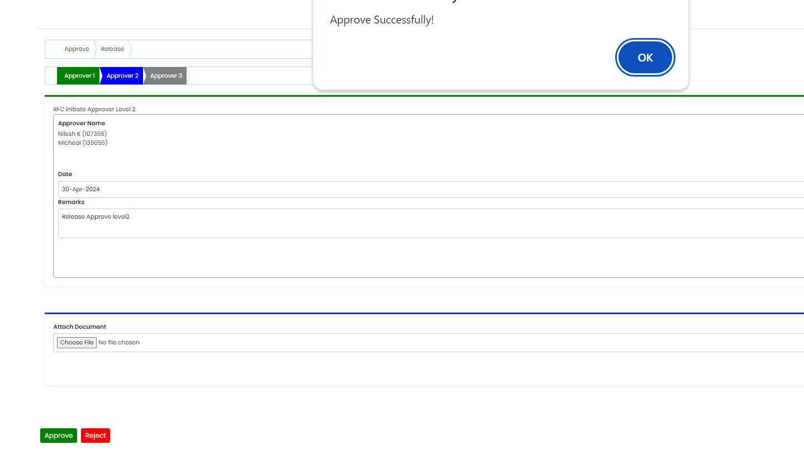

Once the Approver level 2 notes have been successfully Updated, the CR's stage will shift to Release and its status to Approved level2.

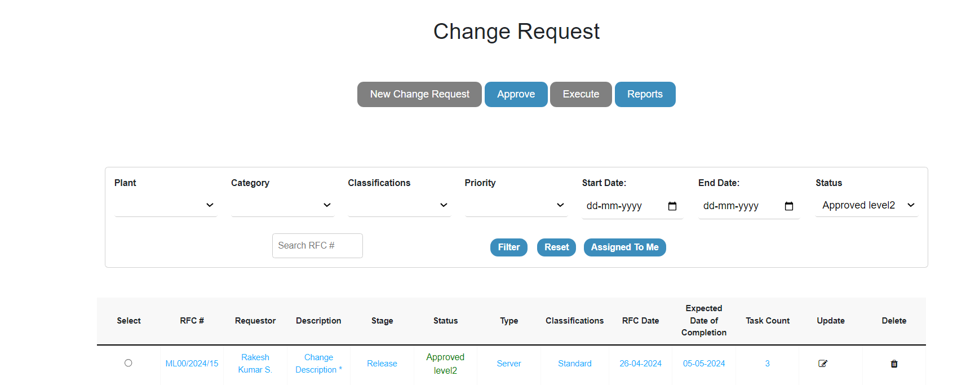

Now that we are in the level 3 phase, you can see that the approver level 1 colour and 2 has changed from blue to green. As the level level 2 approver, you will not have access to approve the level 3 and will not be able to see the name of the level 2 approver and the following buttons- Approve and Reject. So, the following CR must be approved by level 3 approvers, and once the level 3 approver Capture the remarks and click on approve, and the remarks are saved and a popup message appears stating that you have approved successfully.

the CR's stage will shift to Release and its status to Approved.

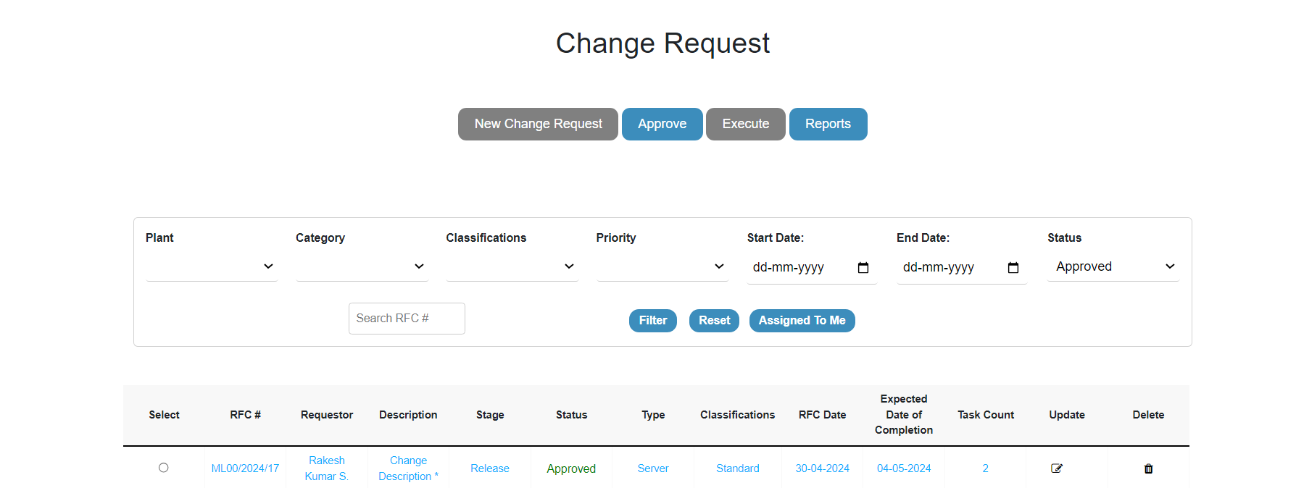

Submit for release:

Once all of the approver levels have been completed, the Status has been updated to released, and the approver will no longer be able to process the CR; instead, it is submitted by the CR owner/initiator for closure, to do so selcect the particular CR and click on the execute, click on Release button which is blue in colour then again click on release which is next to approver. Then it will give you a screen as given below.

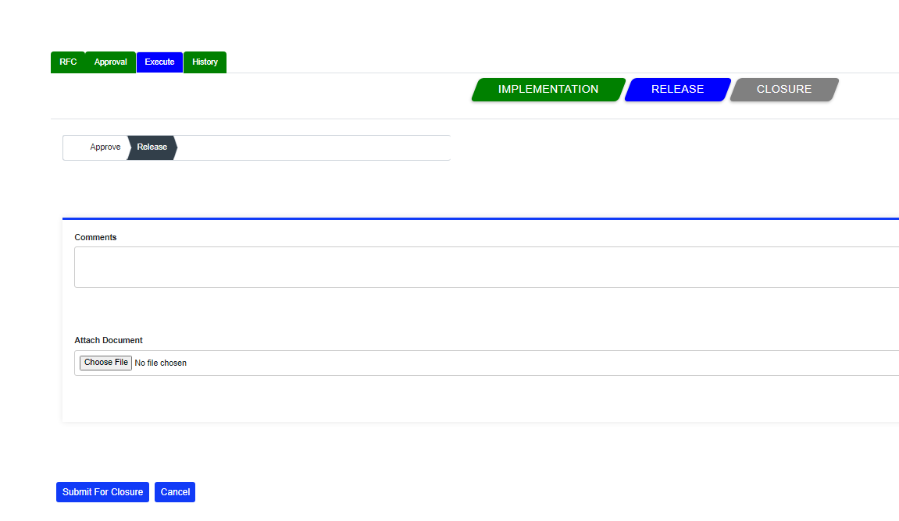

Once you captured your comments and when you select Submit for Closure, a popup message appears indicating "Released Successfully."

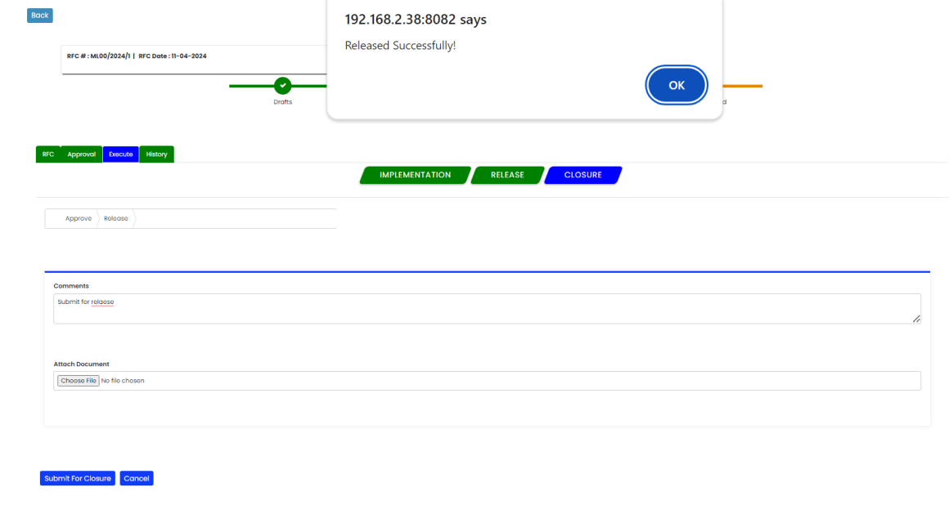

When a submit for closure button is hit, the stage of the specific CR is updated to Release, and the CR's status is updated to Released.

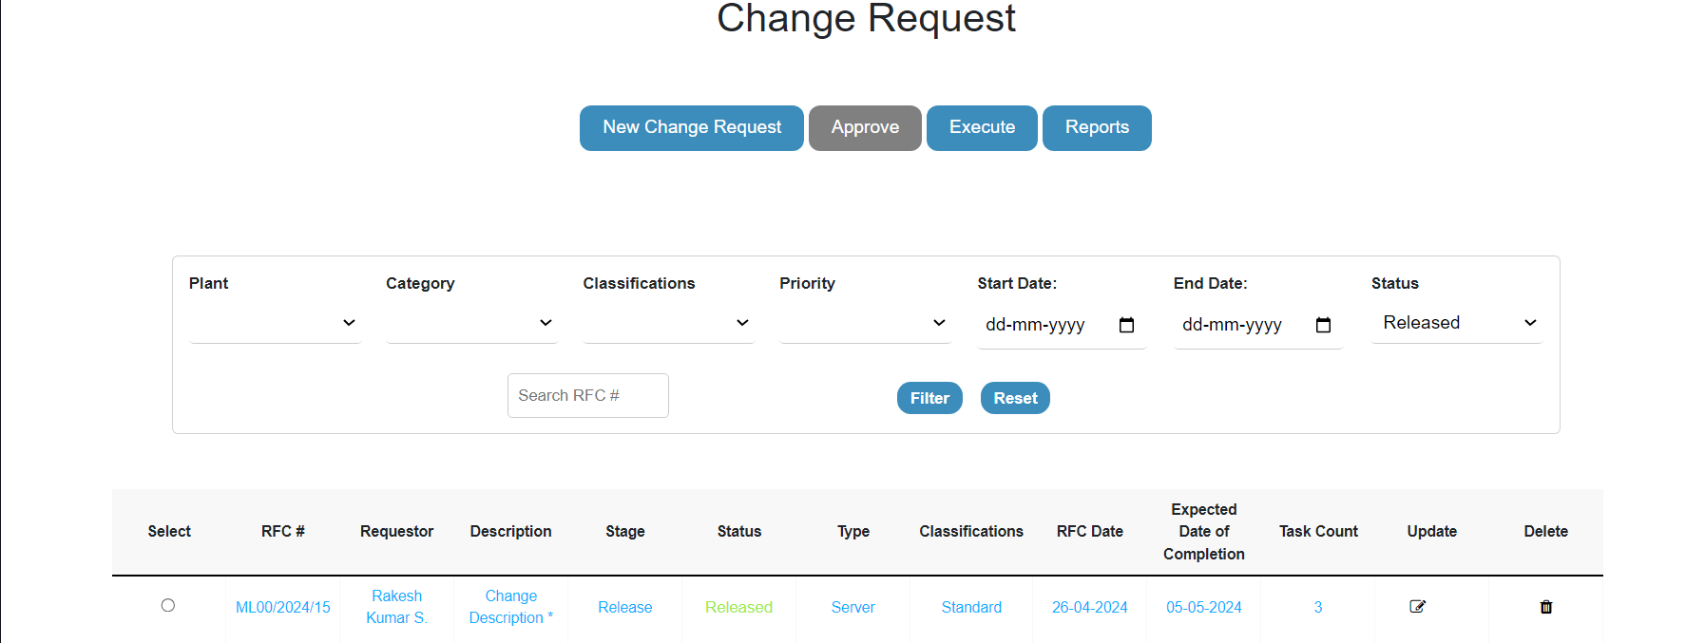

Once the release is done, the status bar for the particular CR will update as released, and the release button will change green in colour and the closure will be in blue, indicating that the release is complete.

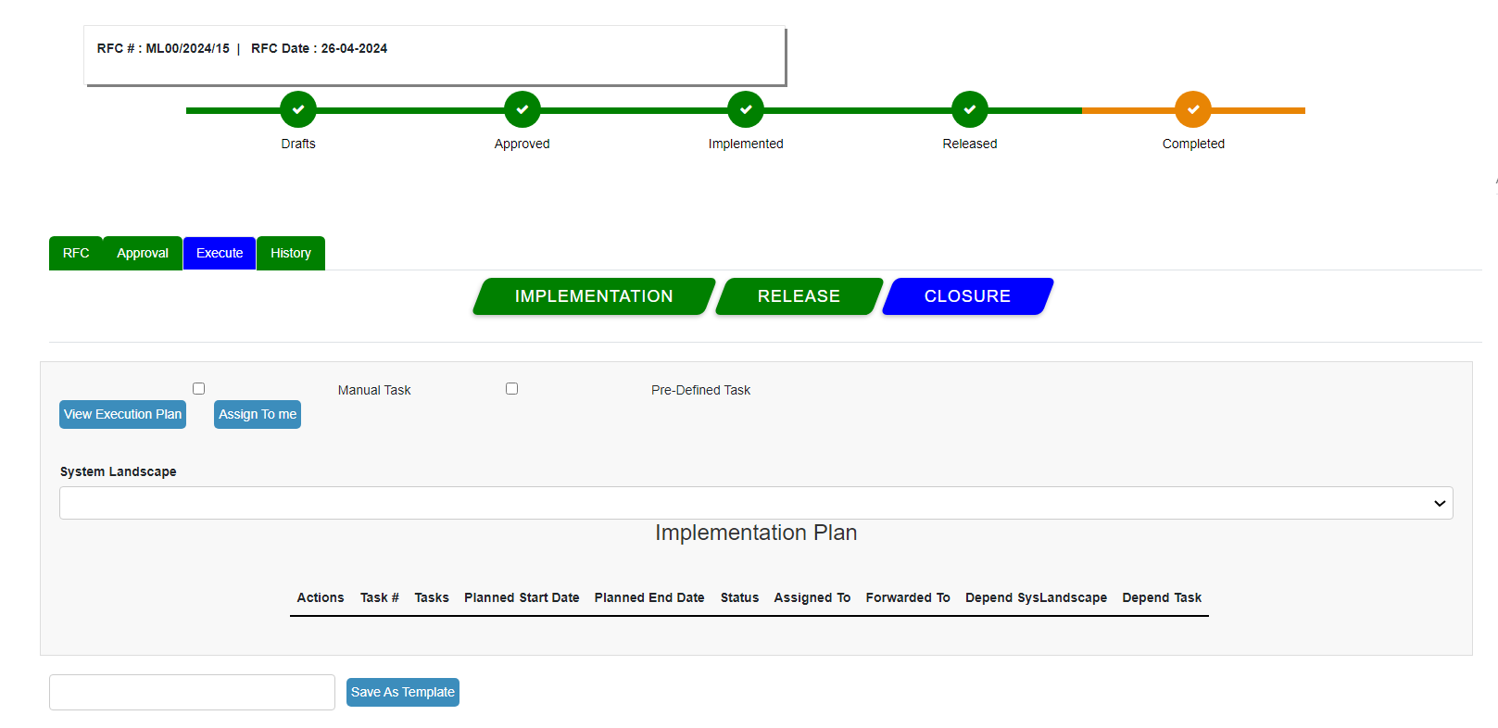

Closure Approver:

After the release is completed, the following step is Closure approver. When you click on closure, a screen will appear with the following details: approver-closure-follow up-lessons learned, while the status indicator for Complete will be orange in colour.

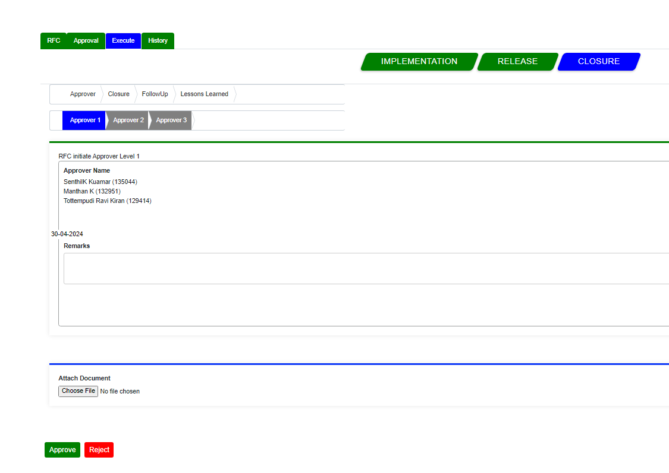

click on Approver, Approver1 By doing this we will enter the Closure approver phase 1, first capture the Remarks, and click on the Approve button a popup message will appear saying that you have approved successfully and the Stage will be updated to closure and the status is approved level 1

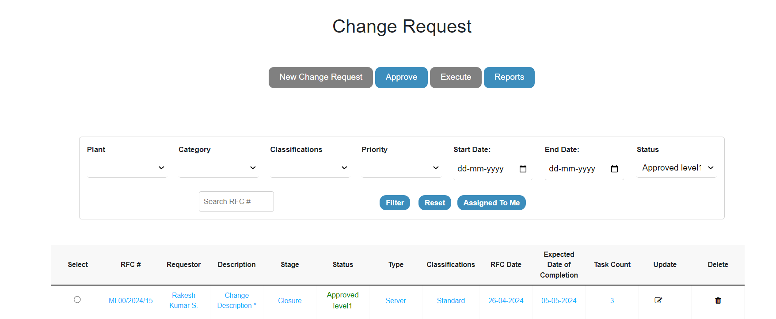

To enter the closure approver level2 phase select the particular CR and click on approve it will take you in and click on closure, click on approvers then click on approver2, as a level 2 approver, you can see that approver2 is blue, which indicates that you are in the approval level 2 phase. update the remarks and click on Approve button.

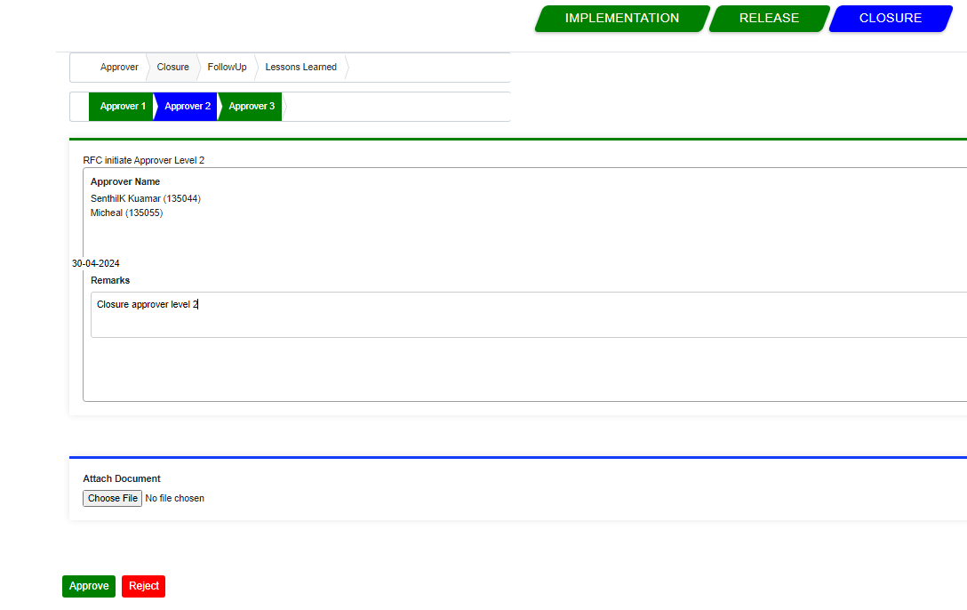

and the remarks are saved and a popup message appears stating that you have approve successfully.

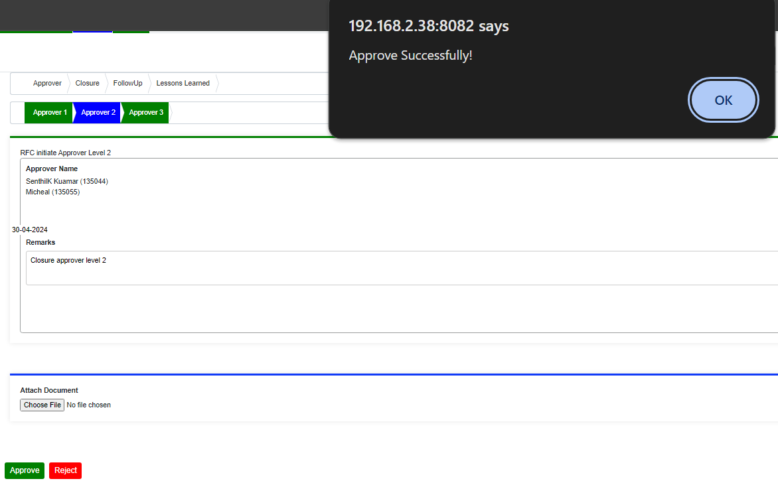

and the Stage will be updated to closure and the status is approved level 2 as shown below.

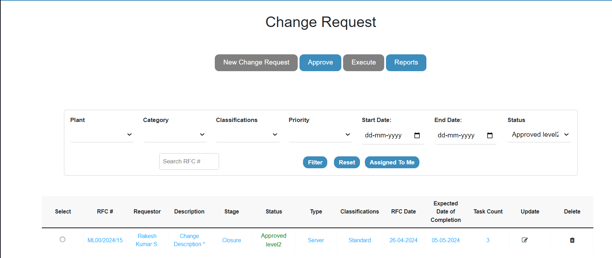

Now that we are in the Closure approver level 3 phase, you can see that the approver level 1 colour and 2 has changed from blue to green. As the level 2 approver, you will not have access to approve the level 3 and will not be able to see the name of the level 2 approver and the following buttons- Approve and Reject. So, the following CR must be approved by level 3 approvers.

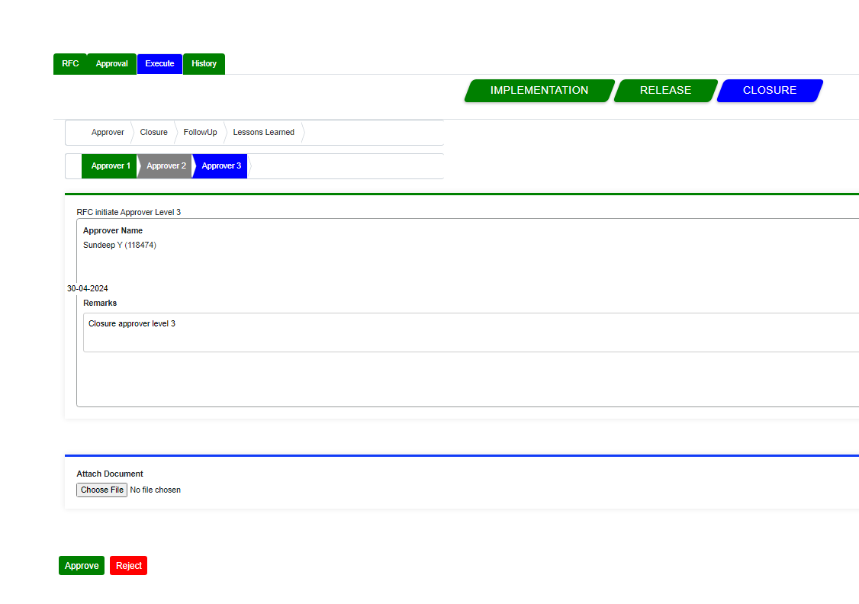

once the level 3 approver Capture the remarks and if required you can also attach the documents then click on approve, and the remarks are saved and a popup message appears stating that you have approved successfully.

the CR's stage will shift to Closure and its status to Approved.

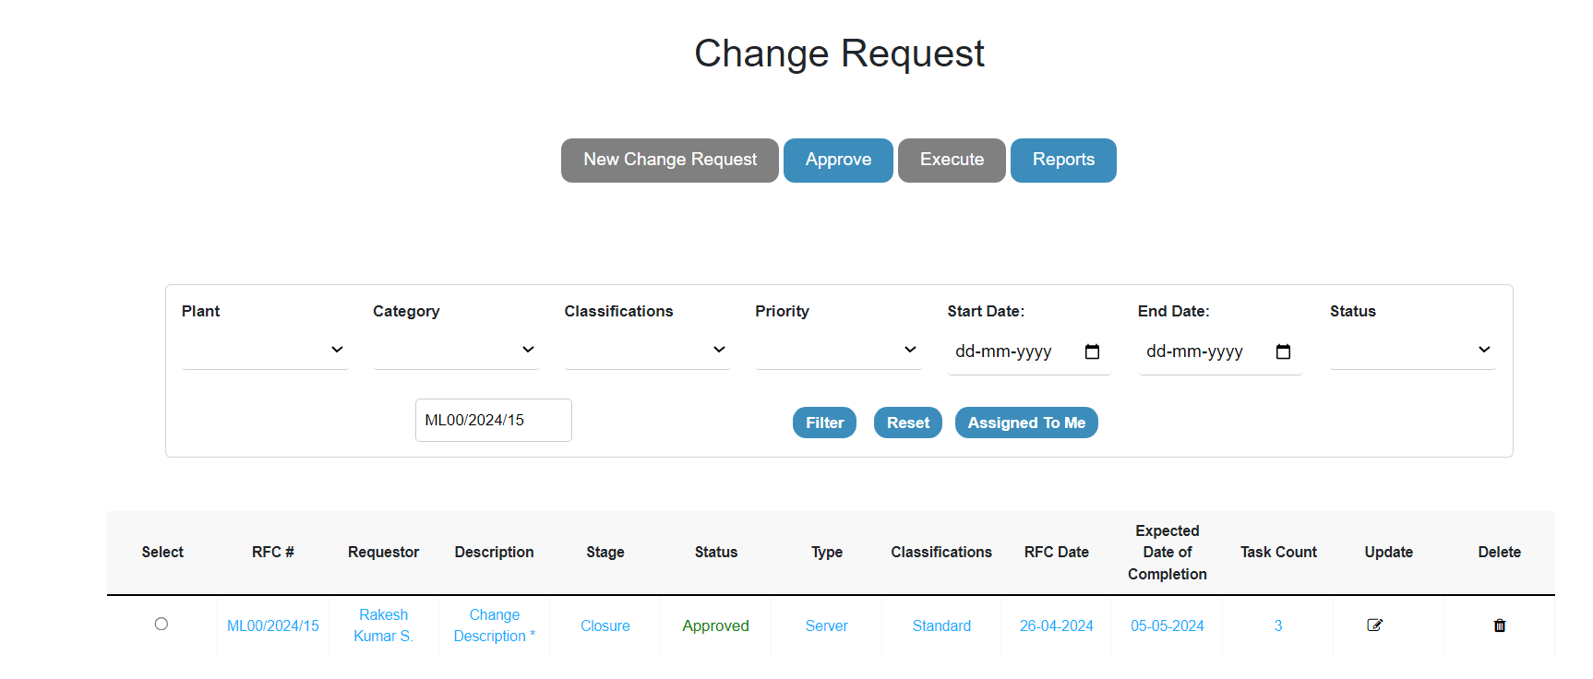as the Closure Approver is done all the levels approver buttons has turned green in colour which means that the closure approver level 3 is completed. we will move towards the closure functionality.

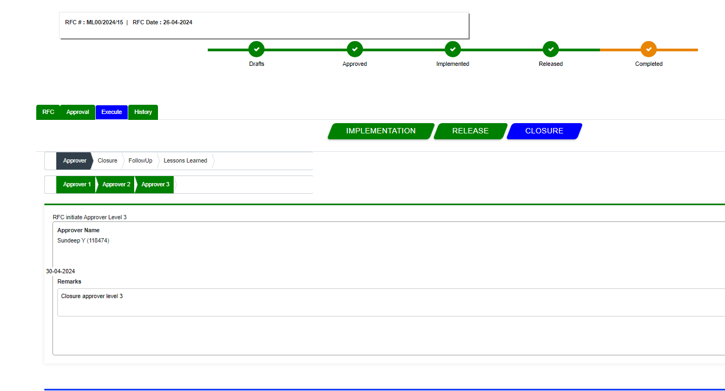

Once all of the approver levels have been completed, the Status has been updated to Closure, and the approver will no longer be able to process the CR; instead, it is submitted by the CR owner/initiator for closure, to do so selcect the particular CR and click on the execute, click on Closure button which is blue in colour then again click on Closure which is next to approver. Then it will give you a screen as given below.

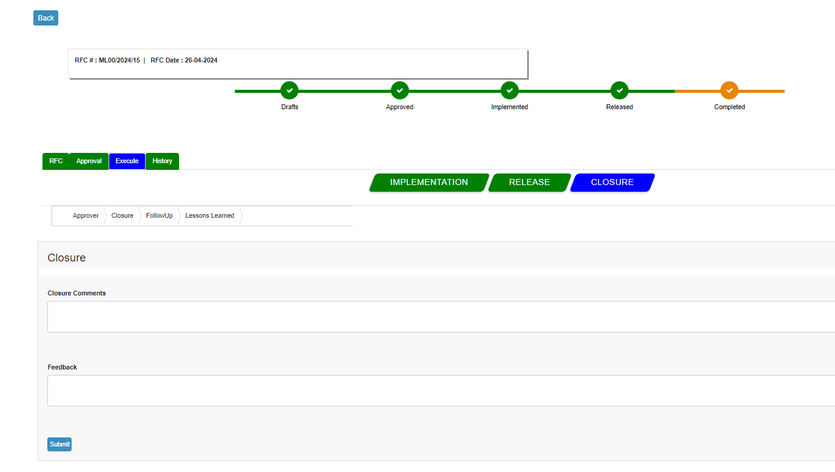

Here comes the final part of the particular CR where the Owner/initiatior Will close the CR by selecting based on Statuses in the Dropdown as shown below.

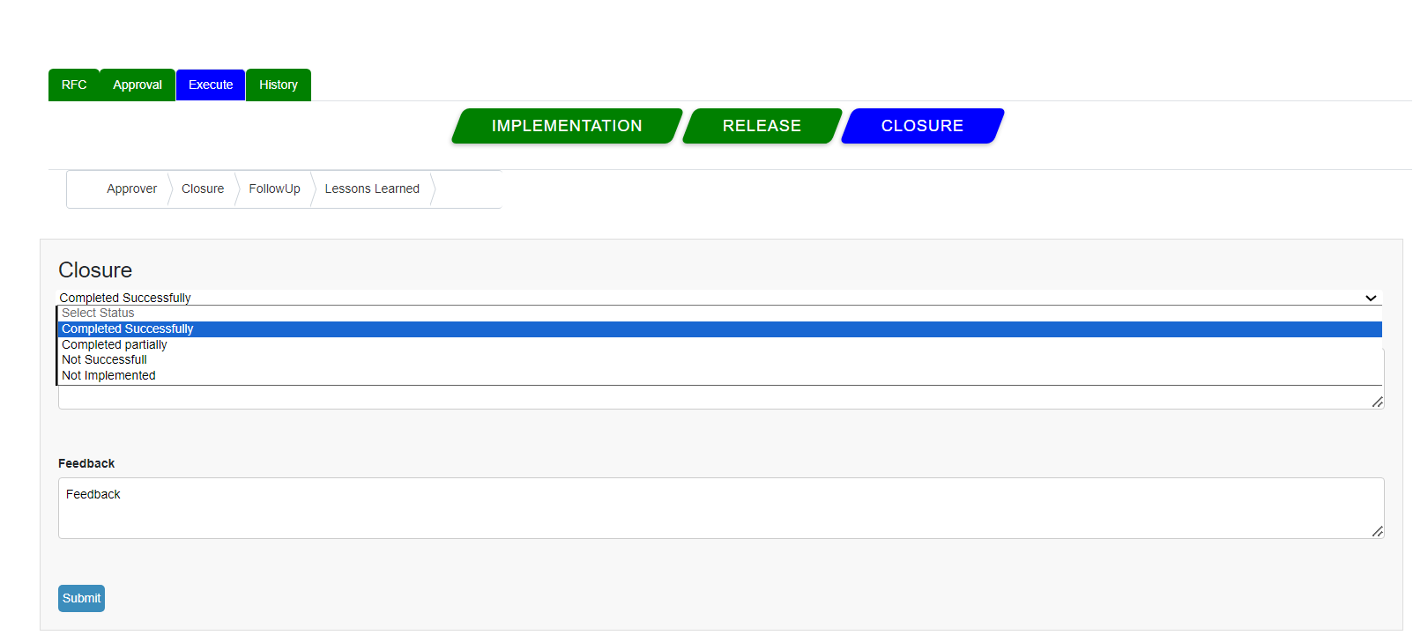

Once the closure is done based on selecting the Status from the Dropdown and capturing the closure comments and feedback as clicked on submit a popup message appears stating that you have Closed successfully as shown below.

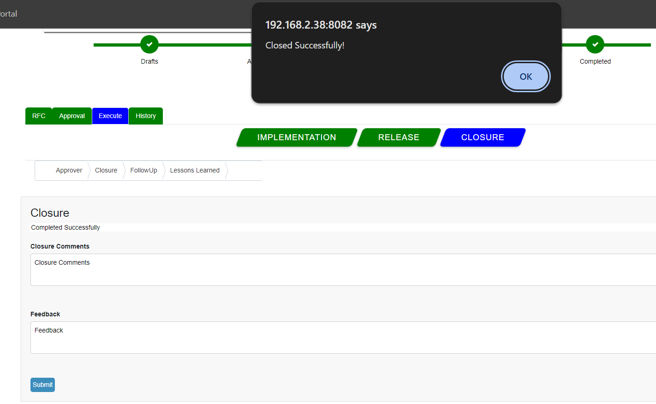

the CR's stage shift to Closure and its status to Completed the status bar also get updated to completed as shown below.

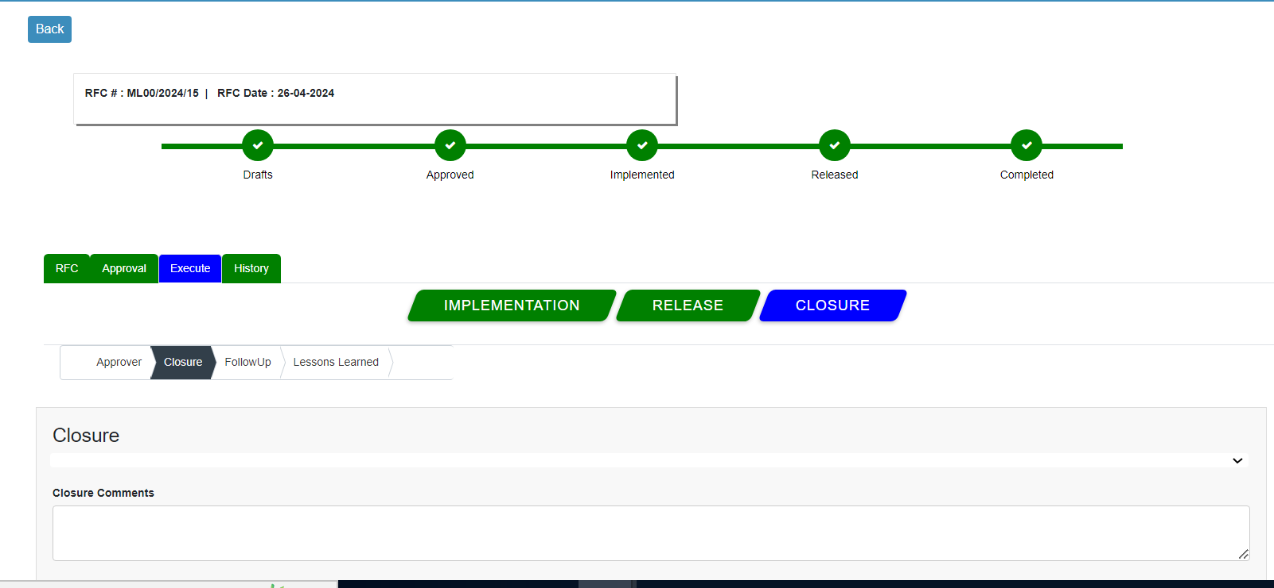

Once all the approvers levels are completed and closure is done the CR's stage will shift to Closure and its status to Completed.

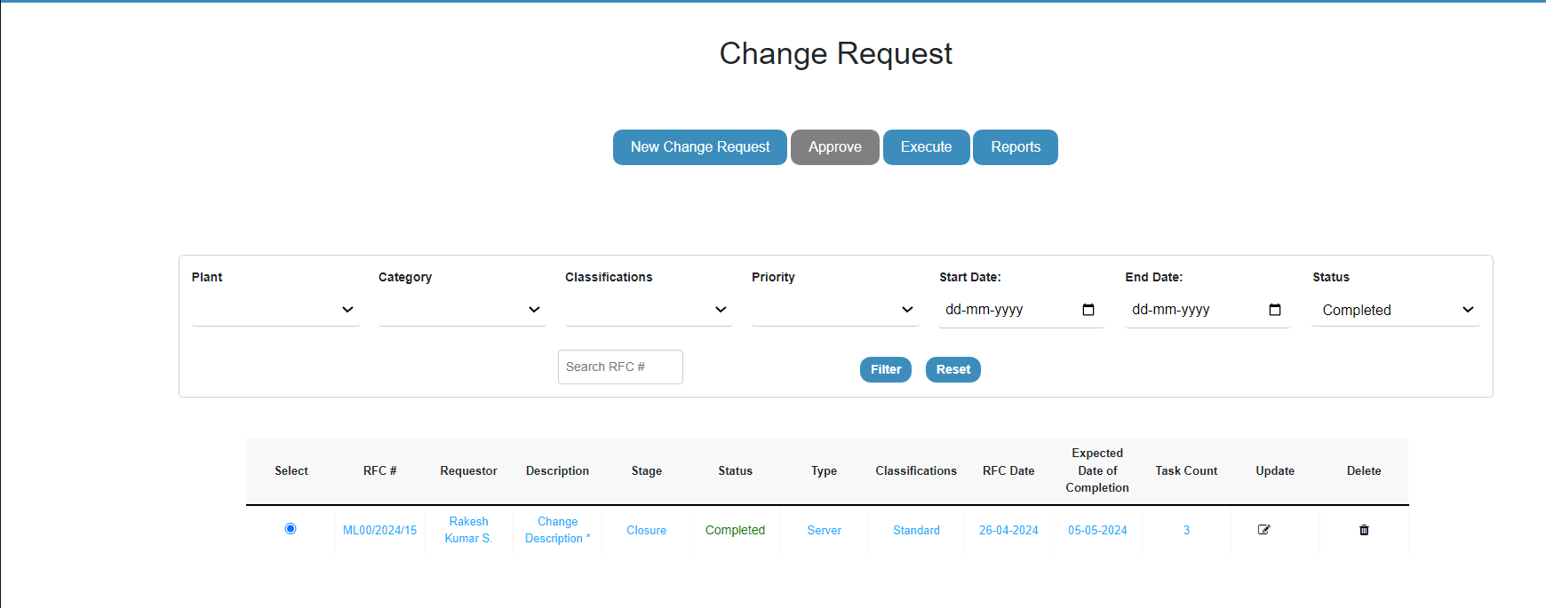

A support engineer can still do the follow-up on the same CR if have any and also can capture the Follow-up comments or the same and click submit button.

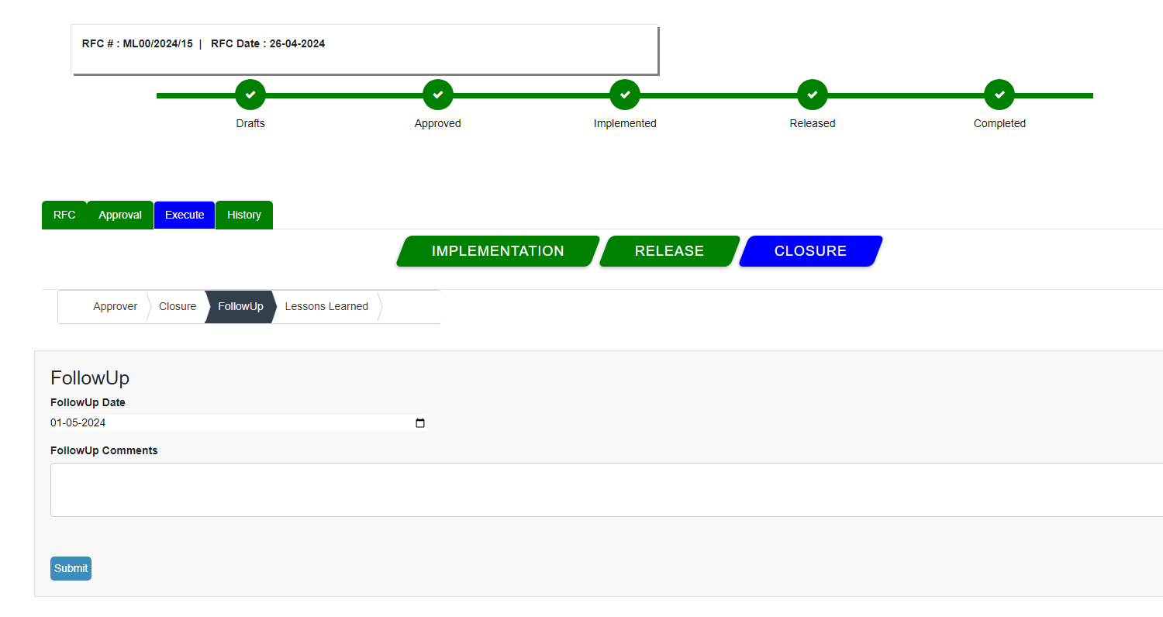

It will give a pop message saying followup saved successfully.

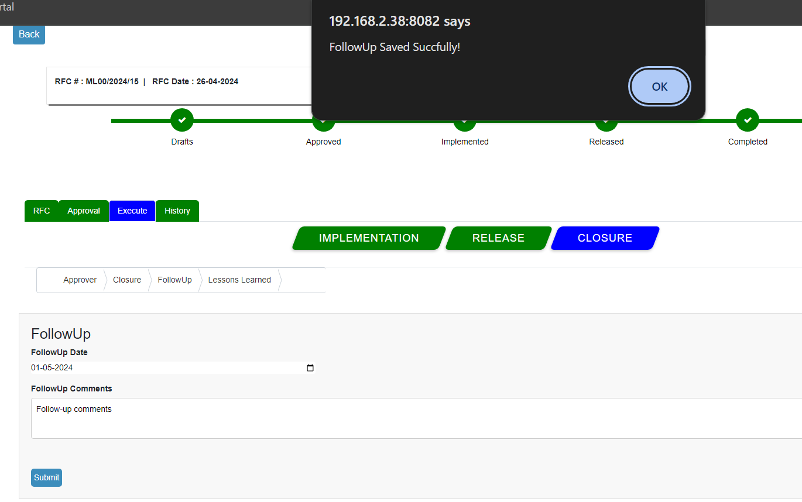

Also support engineer can also update lesson learned any also do add more by clicking on add Lesson button, user can also attach required document if needed.

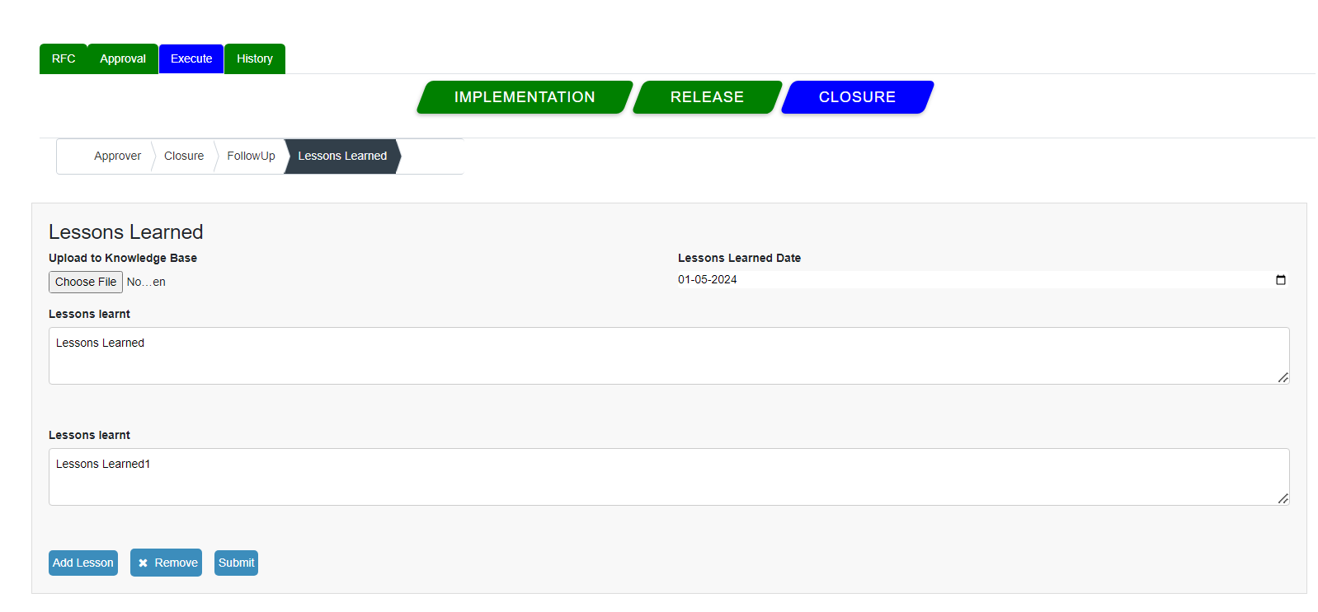

Once the all lesson learned submitted by the User it will give a pop up message saying lesson saved succeffully.

